

Microsoft Azure

Machine Learning

Lab

Table of Contents

Executive Overview 2

First time set-up instructions 3

Copying data to Azure SQL database 3

Creating a new experiment and reading data from Azure SQL 6

Data exploration 9

Training and testing binary classification model 11

Optional: Parameter optimization 15

Performance Evaluation 17

Writing predictions to Azure SQL database 18

Executing R scripts 19

Creating a web service for binary classification model 22

Azure ML Web service call from RStudio 25

Optional: Visualizations for classification using Power View 27

Optional: Clustering 29

Optional: Visualizations for clustering using Power View 32

Summary 36

Appendix A: Uploading a Dataset from Local Machine to Azure ML 36

# Executive Overview

The purpose of this lab is to introduce you to hosting machine learning models in Microsoft Azure cloud, including basic design, experimentation and development tasks. In the lab, we will cover Azure ML Studio, a fully managed machine learning platform that allows you to perform predictive analytics. Azure ML Studio is a user facing service that empowers data scientists and domain specialists to offer customers end-to-end solutions by significantly reducing the complexity to build predictive models. Azure ML provides an interactive and easy to use web-based interface with a drag-and-drop authoring model and a catalogue of modules that encapsulate functionality for the end-to-end model construction workflow.

As a part of the lab, you will be creating two different models based on the dataset called **Churn**. The dataset consists of records belonging to 4667 customers of a fictitious telecom service provider. The columns of the dataset hold information such as the length of customer account, total day, and night, evening and international minutes used.

The first model you will create is called churn analysis known as customer attrition which is the problem of identifying the customers who are likely to leave a service or a business. The goal of the analysis is to contact these high risk individuals and take necessary actions such as providing special offers and discounts to prevent them from leaving the business. You will model the problem using the binary classification technique. Additionally, two optional sections are provided to create a web service for the model and visualizing the classification results using Power View.

The second model you will create is a segmentation model where the objective is to find natural clusters of customers within the data sets who have similar characteristics. This is also extremely beneficial to understand the customer base for targeted marketing applications where the goal is to target the right individuals in order to grow the business.

# Download materials (including this documentation)

To make following along easier, you can download this documentation at <http://aka.ms/AzureMLChurnTutorial>. You also need to go to that URL to download the data that is used in this tutorial.

**Step-by-step**

1. Go to: <http://aka.ms/AzureMLChurnTutorial> and download all the materials by clicking the **Download ZIP** button.
2. Extract (un-zip) these files to have a local copy.

# First time set-up instructions

You will need an Azure Machine Learning workspace for this lab. There is a free and a standard tier of Azure Machine Learning – we will use the free tier in this lab. For more details, see pricing page here: <https://azure.microsoft.com/en-us/pricing/details/machine-learning/>.

**Step-by-step**

1. Go to <https://azure.com/ml>. Click on **Get Started Now** link on top-middle part of the page.
2. We recommend doing ‘**Sign In’** option to create a free tier workspace, so that the work you do as part of the tutorial today can be later accessed. If this doesn’t work for you, **Guest Access** will also work for the tutorial (but you will not be able to access your work again another day). If your email address is already a “Microsoft account” then simply sign in, otherwise you can click to ‘**Don't have a Microsoft account? Sign up now**’ and associate your email with a Microsoft account to log in.

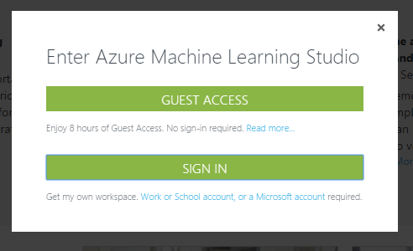

1. Once you have signed in, Azure ML Studio will ask you if you’d like to take a tour. Click on “**Take Tour**” and walk through the steps to understand the basics of the Studio.

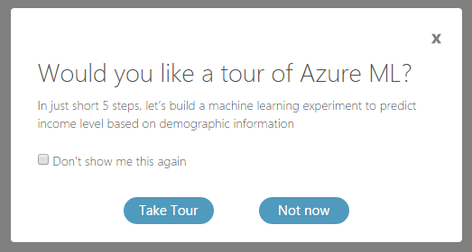

1. When you are finished, click on “finished” to get back to the Studio. You should then have a workspace that looks something like this:

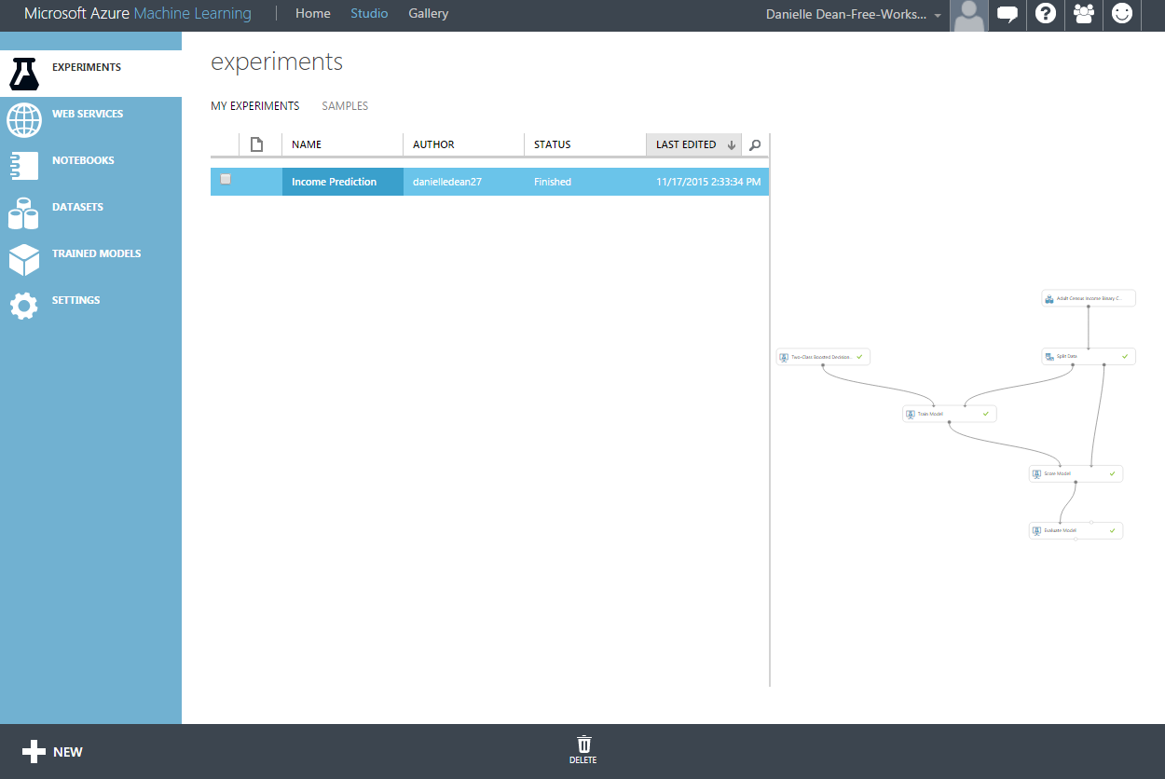

# Uploading a Dataset from Local Machine to Azure ML

In this exercise, you will upload a new data set stored on your local machine in the form of a .csv file. This step takes about 5-10 minutes to complete.

**Key Points**

1. The table includes information about 4500 fictitious individuals that are subscribed to a mobile telecommunications service provider.
2. The information contained in the table includes the length of the account, plan subscriptions, international minutes, etc…

**Step-by-step**

1. The data file is part of the ZIP file that was downloaded in the first part of the tutorial from github (<https://github.com/dneled/Strata-2015-12>). Once the folder is extracted, the CSV is called **CustomerChurnData.csv**.
2. Click on **+New** link at the bottom left corner of Azure ML Studio. Click **DATASET** on the left bar and then **FROM LOCAL FILE**. Browse to the location where you downloaded the file and select the file **CustomerChurnData.csv**. Notice that the type of the data set is set to **Generic CSV File with a header (.csv)** and click the check mark at the bottom of the window.

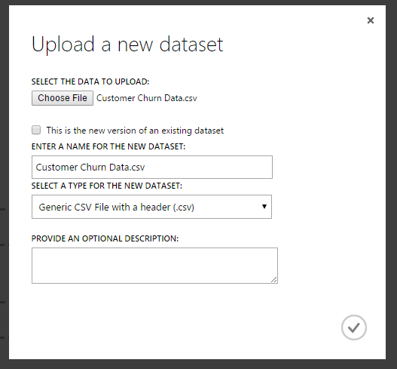

1. You now have a new dataset called CustomerChurnData.csv which you will find under My Datasets category on the modules list (you will see this in Section 4 that follows).

# Data exploration

First step in any data science project is to explore and understand the data. This requires some statistical analysis and visualizations to get a better view about its properties which are important criteria when deciding which machine learning model fits well for the data. To do this, we first need to create an Azure ML experiment – experiments allows us to create machine learning workflows with the drag-drop environment, or we can create a IPython Notebook which allows us to use Python code interactively with the data. Then we can start exploring the data in more detail. In the steps that follow, we will do both options, so you can see what works best for you.

**Step-by-step**

1. Click on **+New** link at the bottom left corner of Azure ML Studio and click on **EXPERIMENT** and then click on **Blank Experiment** on the top left corner. This will open a blank experiment.
2. You should see the Customer Churn Data within the **My Datasets** section of **Saved Datasets**. Drag the module onto the experiment canvas so we can start the experiment with that data. You can also rename the experiment at the top of the screen if you wish to something like **Churn Prediction**.

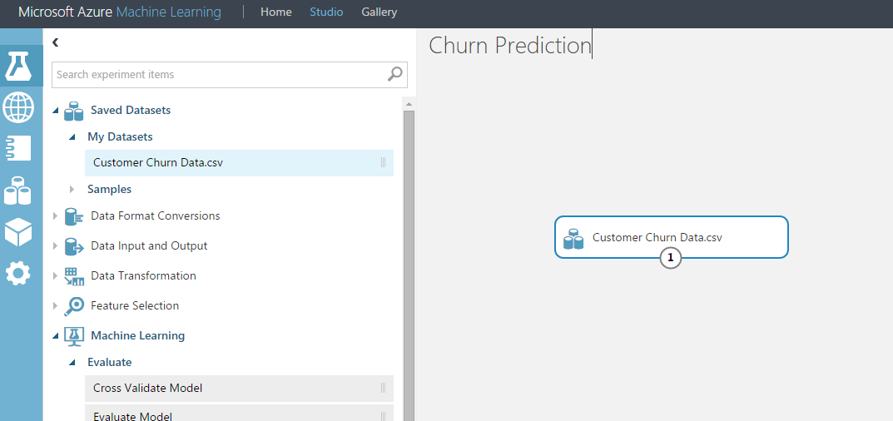

1. Select the dataset module that you’ve pulled onto the canvas, and right click the (1) that is at the bottom of the module. This is the outport port. Select **Visualize** to see the data and make sure it was read in correctly.

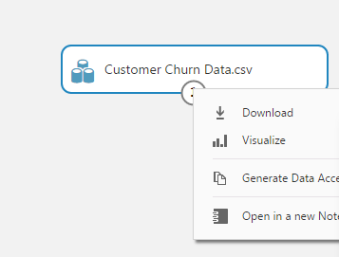

1. You should have 4,667 rows with 22 columns, and the data should have headers.

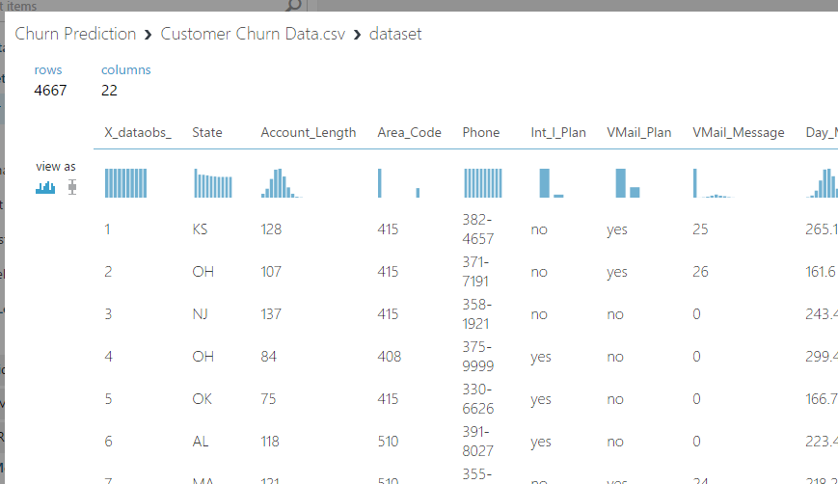

I need to open up a blank notebook in AML first, then click on File→Open…→upload to upload a local notebook.

# Training and testing binary classification model

There are five main machine learning techniques you can perform using Azure ML Studio. These are Anomaly Detection, Classification, Clustering, Regression, and Recommender methods. In this section, we will focus on creating a Binary Classification Model.

**Key Points**

1. There is an extensive library of binary classification algorithms included in Azure ML Studio. Most popular ones are Boosted Decision Trees, Logistic Regression and Support Vector Machines. You are strongly encouraged to research about these algorithms to get a better understanding of the techniques.
2. Before applying any machine learning model, an important step is the data cleaning and preparation. As an example, in this exercise, you will reduce down the dataset by eliminating highly correlated variables identified in the earlier steps.
3. In order to assess the quality of models, a common method in machine learning applications is to separate the data into **training** and **test** sets to measure the accuracy of predictions. In this part of the lab, you will first train the model with 70% of the total data points and test it with the remaining 30% of the data in order to assess the performance of the model.

**Step-by-step**

In this part, you will extend the experiment for training a binary classification to identify customers who are more likely to churn. This step takes about 20 minutes to complete.

1. First, you will use the **Project Columns** module to exclude **Day_Charge**, **Eve_Charge, Night_Charge** and **Intl_Charge** columns since these are highly correlated with **Day_Mins**, **Eve_Mins**, **Night_Mins** and **Intl_Mins**. You will also exclude **Area_Code** and **Phone** number.
2. Click on the Project Columns module and click **Launch column selector** in the properties menu bar on the right side. In the text box, next to X_dataobs_ feature, enter the following columns: **Area_Code**, **Phone**, **Day_Charge**, **Eve_Charge**, **Night_Charge** and **Intl_Charge** and click the check mark.

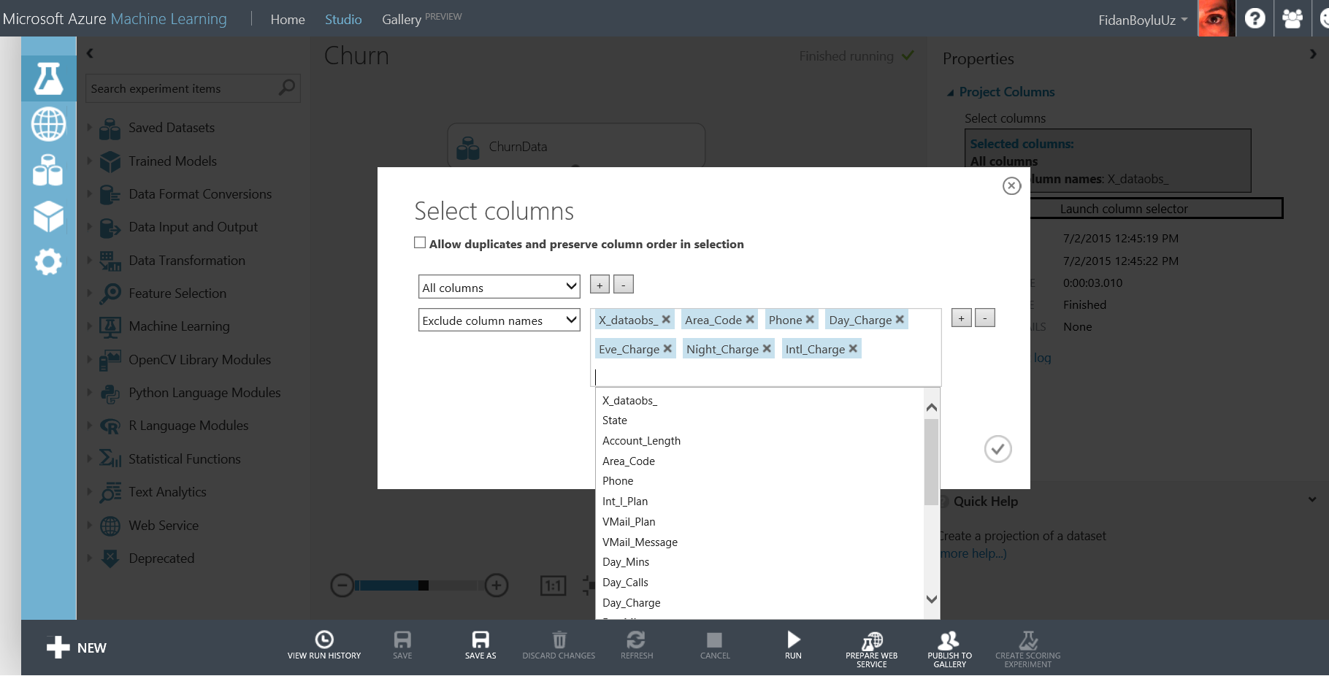

1. Next, on the left side navigation bar, type **Split**, drag/drop the module to the experiment and connect the output port of **Project Columns** module to the **Dataset** input of **Split**. Rearrange modules as in the screenshot below. Next, click **Split** and on the **Properties** navigation bar on the right side, type **0.7** in the textbox for **Fraction of rows in the first output dataset** and **1234** in **Random seed** textbox. Random seed is used to start the random process from the same seed every time the experiment is re-run.

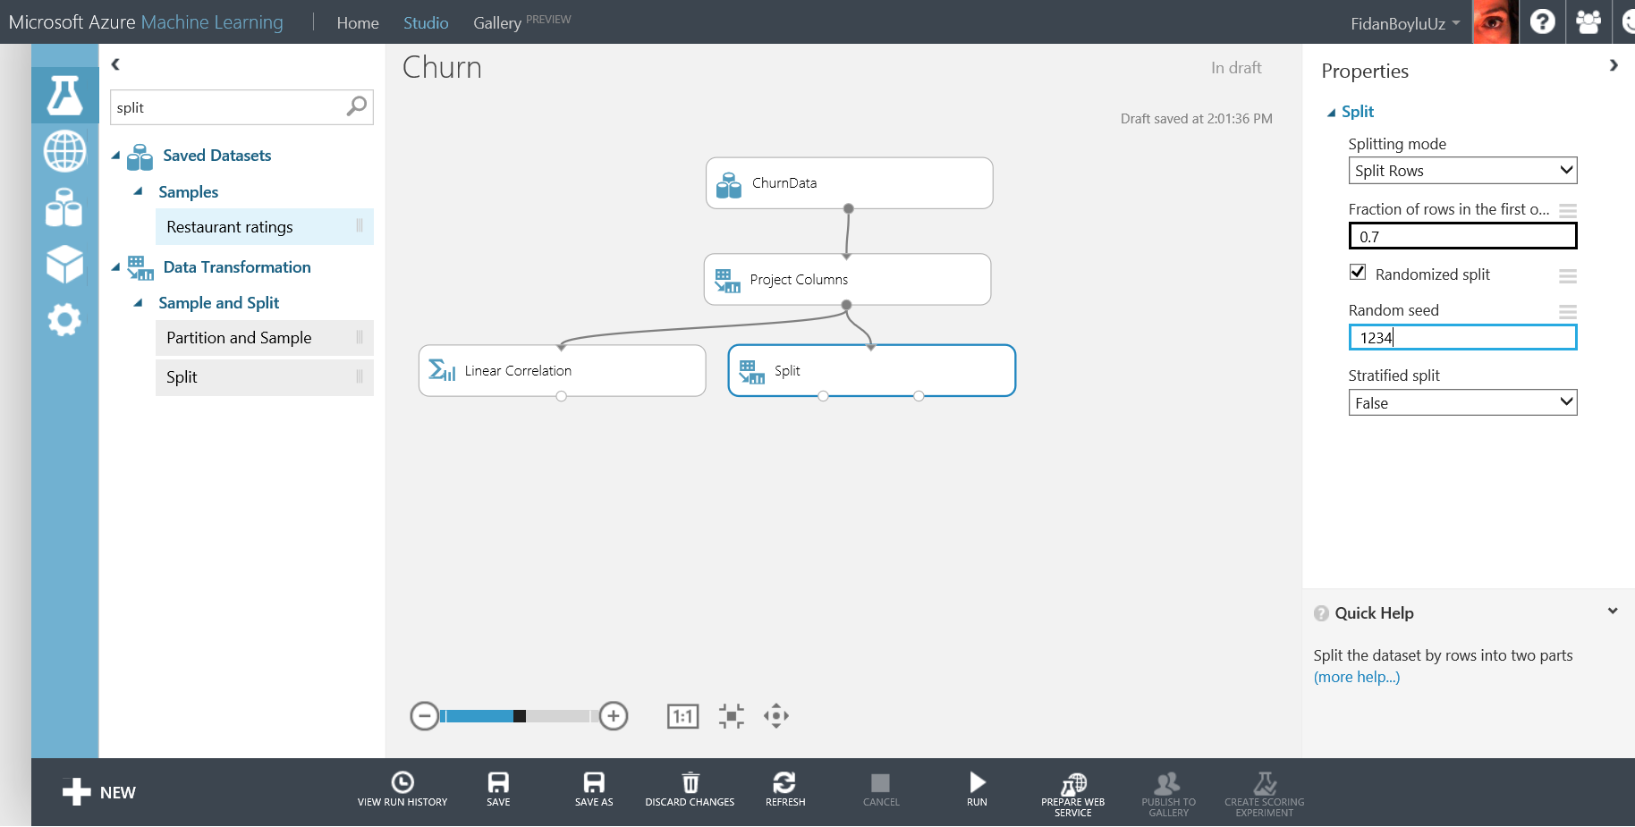

1. Now, on the left side navigation bar, type **Machine Learning** and under **Initialize Model, Classification** category**,** drag/drop **Two-Class Boosted Decision Tree** moduleon the experiment canvas. Next, under **Train** category, drag/drop **Train Model.** Connect **Results dataset1** output port of **Split** module to the **Dataset** input of **Train Model.** Also, connect **Untrained model** output port of **Two-Class Boosted Decision Tree** to the **Untrained model** input port of **Train Model.**

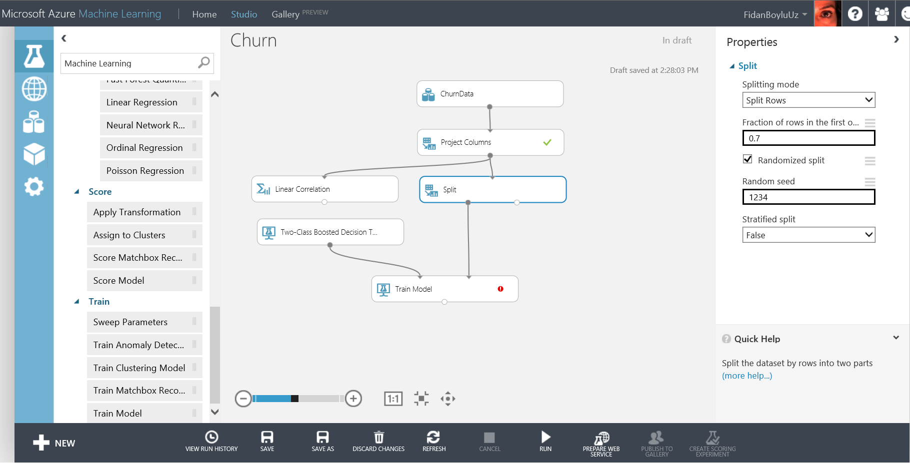

1. Click **Train Model** and on the Properties navigation bar on the right side, click **Launch column selector**, select **Column names** in the first drop down menu and type or select **Churn_** in the textbox and click the check mark at the lower right corner.

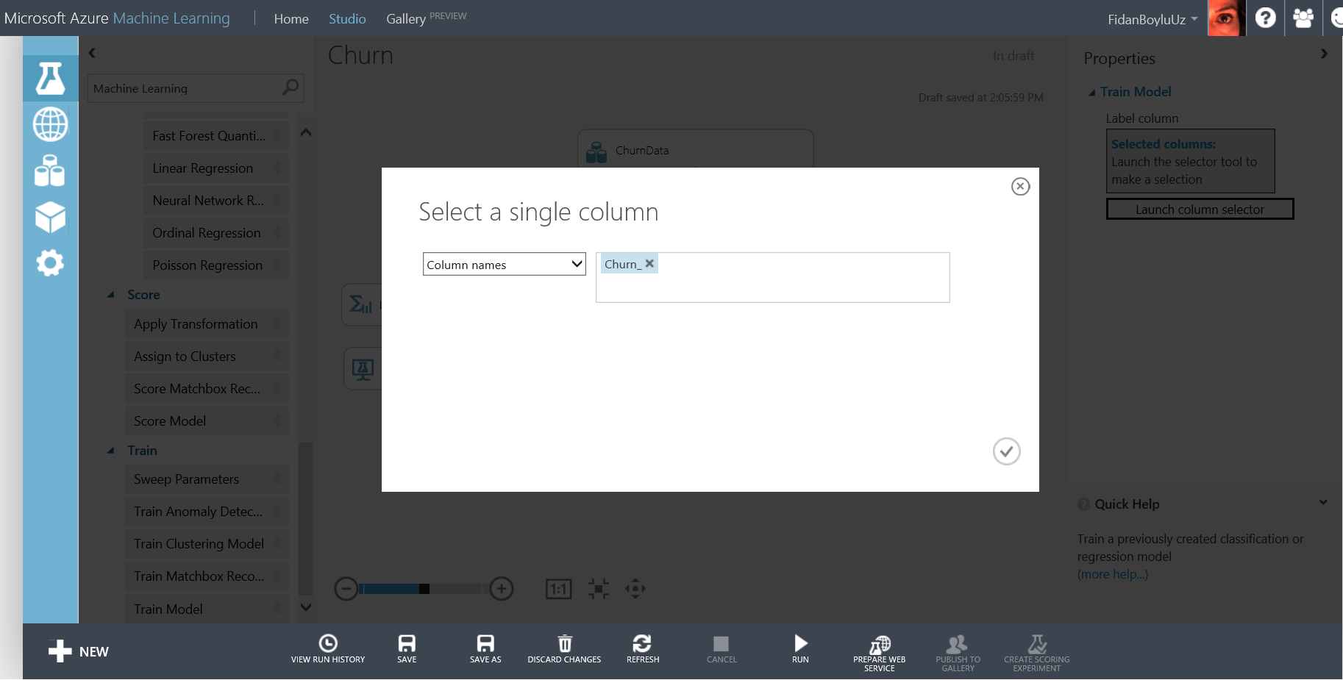

1. Type **Score Model** in the search box on the left navigation pane and drag/drop the module to the experiment canvas. Double click that module and type **Training** in the Label box (use the arrow to unhide the label). Connect **Trained model** output of **Train Model** module to the **Trained model** input of **Score Model** module. Next, connect **Results dataset1** output port from the **Split** module to **Dataset** input port of **Score Model** module and click **Run** at the bottom menu bar.

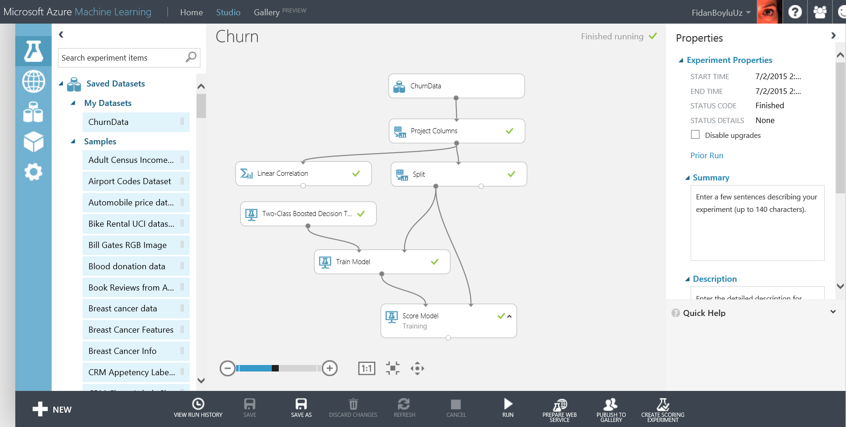

1. Make sure all modules have green check marks and experiment is finished. Right click **Scored dataset** output port of **Score Model / Training** and select **View Results**. In the output page, scroll right to the end and observe the **Scored Labels** and **Scored Probabilities** columns. These are the predictions that the trained model has made on the top 100 training dataset rows. Scroll down and compare **Churn_** column with **Scored Labels** column to identify any false positives and false negatives. You will mostly find correct classifications where Churn_ and Scored Labels columns have the same value. We will look into the classification error (false positives and false negatives) in the Performance Evaluation section. Close the page using the close button on the upper right corner.

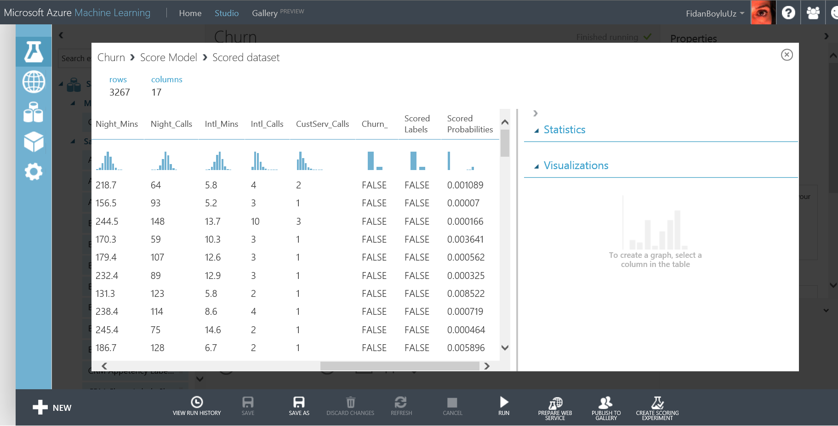

1. For testing, search for **Score Model** module again and drag/drop on the experiment. Double click the module and type **Testing** in the Label box. Connect the **Results dataset2** output of the **Split** moduleto **Dataset** input of **Score Model - Testing**. Now, connect the **Trained model** output of **Train Model** to **Trained model** input of **Score Model / Testing** and **Run** the experiment.

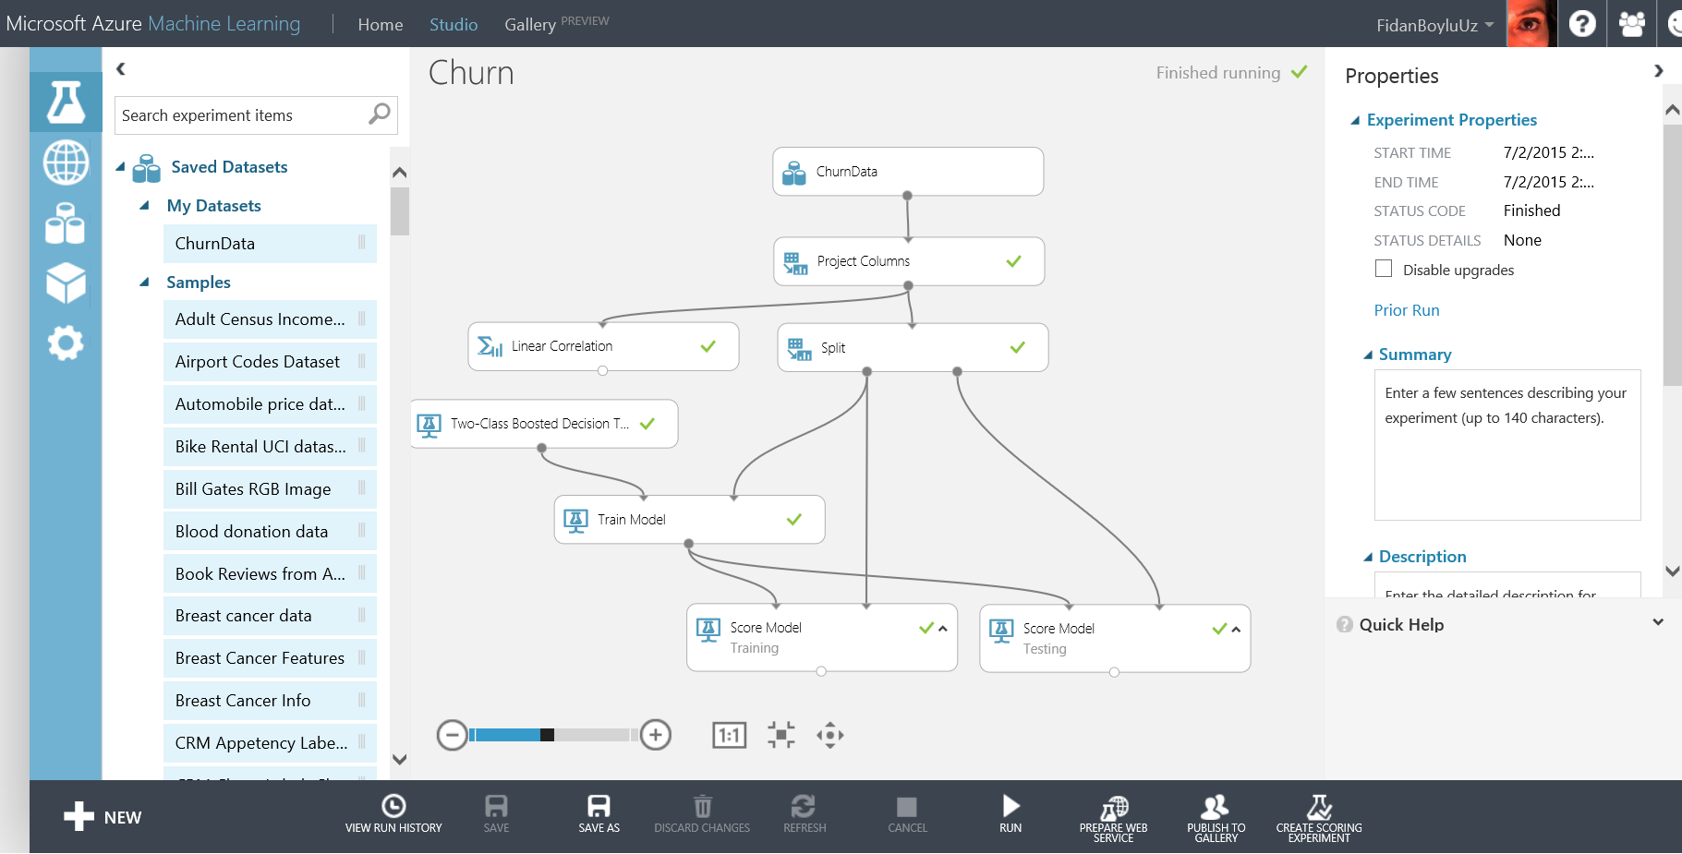

1. Right click **Scored dataset** output port of **Score Model – Testing** and select **View Results**. In the output page, scroll right to the end of the page to observe the **Scored Labels** and **Scored Probabilities** columns. These are the predictions that the trained model has made on the test dataset. Scroll down and compare **Churn_** column with **Scored Labels** column to identify any false positives and false negatives. You will find that the 4th row is misclassified as **TRUE** although the value for the **Churn_** column is **FALSE.** These are called false positives. Close the page using the close button at the upper right corner.

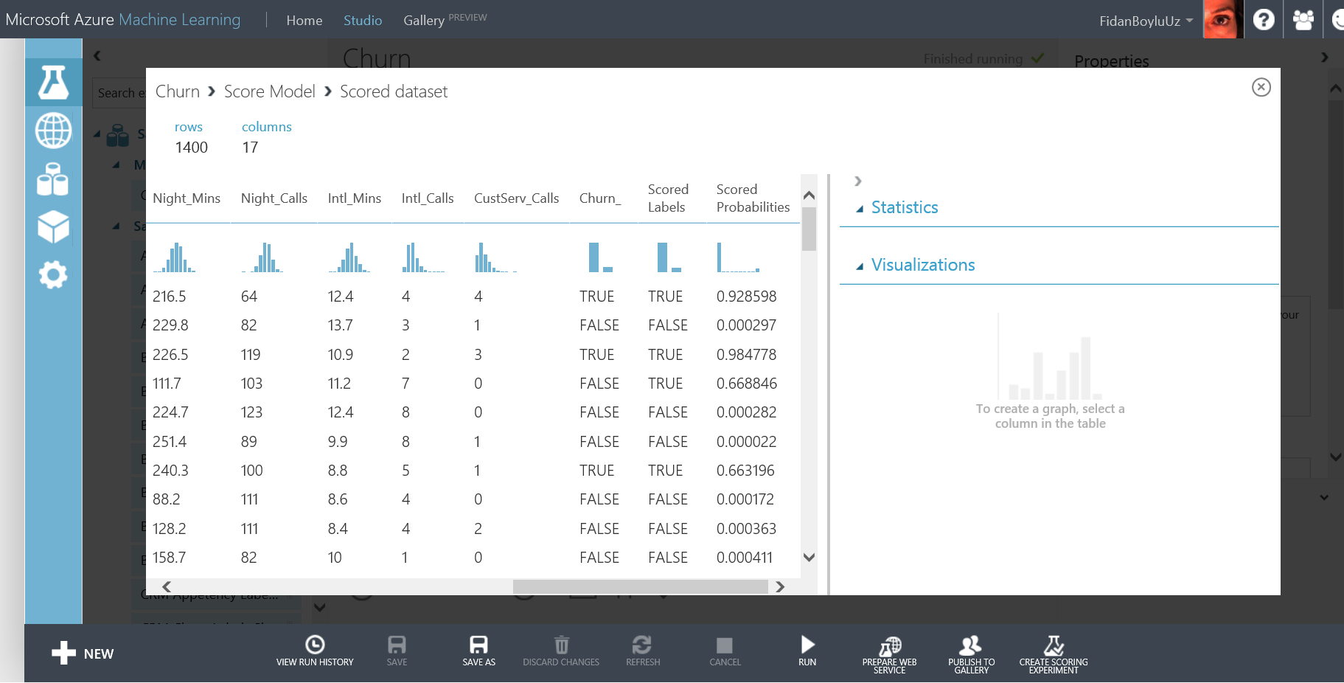

# Parameter optimization

As a next step, you will use **Sweep Parameters** module to fine-tune your models.

**Key Points**

1. Machine Learning algorithms depend on parameters that can change the model performance significantly. The best values for these parameters are not computed while training the models so it is important to try different parameters to find the best performing parameter set.
2. As an example, some of the parameters of Boosted Decision Trees algorithm are number of trees constructed and learning rate.

**Step-by-Step**

1. First, we will create a new experiment called **Churn Sweep Parameters**. Click the **SAVE AS** button at the bottom bar and type Churn Sweep Parameters for the experiment name and click the check mark. You will see that your experiment is renamed. You now have two experiments in your workspace. You can verify that by clicking the experiments tab on the leftmost navigation bar. Notice that a preview of the experiment is displayed on the right side.
2. Go back to Churn Sweep Parameters experiment and in the search experiment items box, search for Sweep Parameters module and drop it on your experiment to replace Train Model module. Observe the Properties of Sweep Parameters. It gives you the option to randomly sweep or sweep over a grid of the parameters of the training algorithm. Refer to the quick help page for more information on the Sweep Parameters module. In the properties pane, leave all options as default. However, you need to use column selector to select **Churn_** column as the label column.

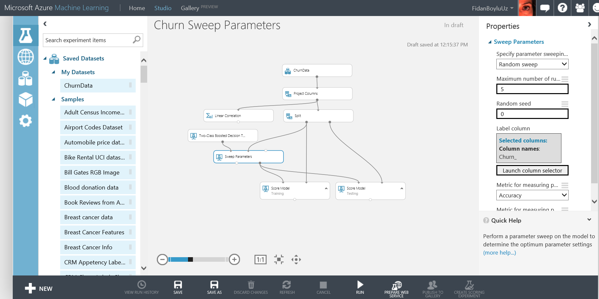

1. Now, select Two-Class Boosted Decision Tree module and on the parameters bar in the first drop down, chose **Parameter Range** and run your experiment. When finished, click on the left output port of Sweep Parameters and observe the random set of parameters that were used to run the experiment 5 times and their performance metrics. These will be discussed in the next sections.

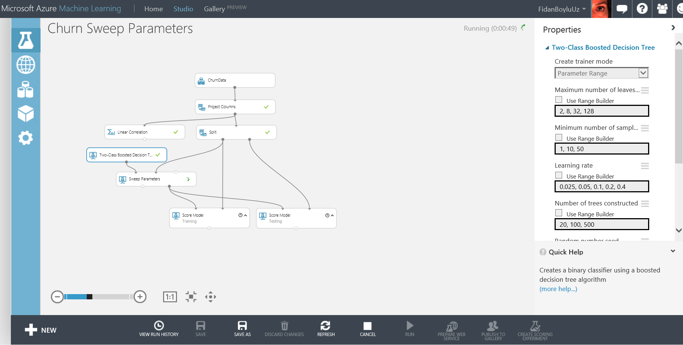

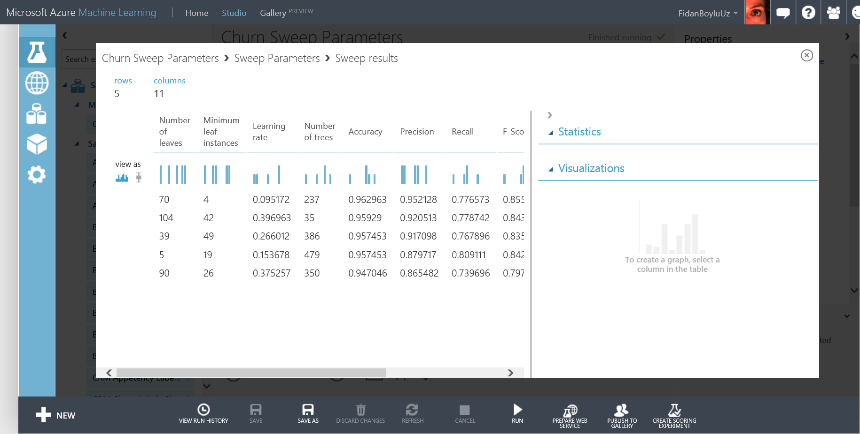

1. Click on the experiments tab and return back to the Churn experiment.

# Performance Evaluation

In this exercise, you will assess the predictive power of the model you have built so far. You will observe the performance of the model on the training set and compare that to the test set to understand the trade-off between over fitting and generalization.

**Key Points**

1. To understand performance of a model, a few basic concepts must be introduced. For binary classification models, there are four possible outcomes:
   1. True Positive (TP) - a positive instance that is correctly classified as positive;
   2. False Positive (FP) - a negative instance that is incorrectly classified as positive;
   3. True Negative (TN) - a negative instance that is correctly classified as negative;
   4. False Negative (FN) - a positive instance that is incorrectly classified as negative).
2. There are three related metrics that are used to measure performance.
   1. Precision is calculated by TP/ (TP+FP)
   2. Recall is calculated by TP/ (TP+FN)
   3. Accuracy is calculated by TP+TN/ (TP+FP+TN+FN).
3. ROC curve is an important performance measure which will be explained in this section.

**Step-by-Step**

This exercise takes about 10 minutes to complete.

1. Go to your Churn experiment. Type **Evaluate Model** to the search box on the left and drag/drop it on the experiment. Connect the **Scored dataset** output port of **Score Model / Training** module to the left side **Scored dataset** input port of **Evaluate Model**.
2. Connect the **Scored dataset** output port of **Score Model / Testing** module to the right side **Scored dataset** input port of **Evaluate Model** and click **Run.**

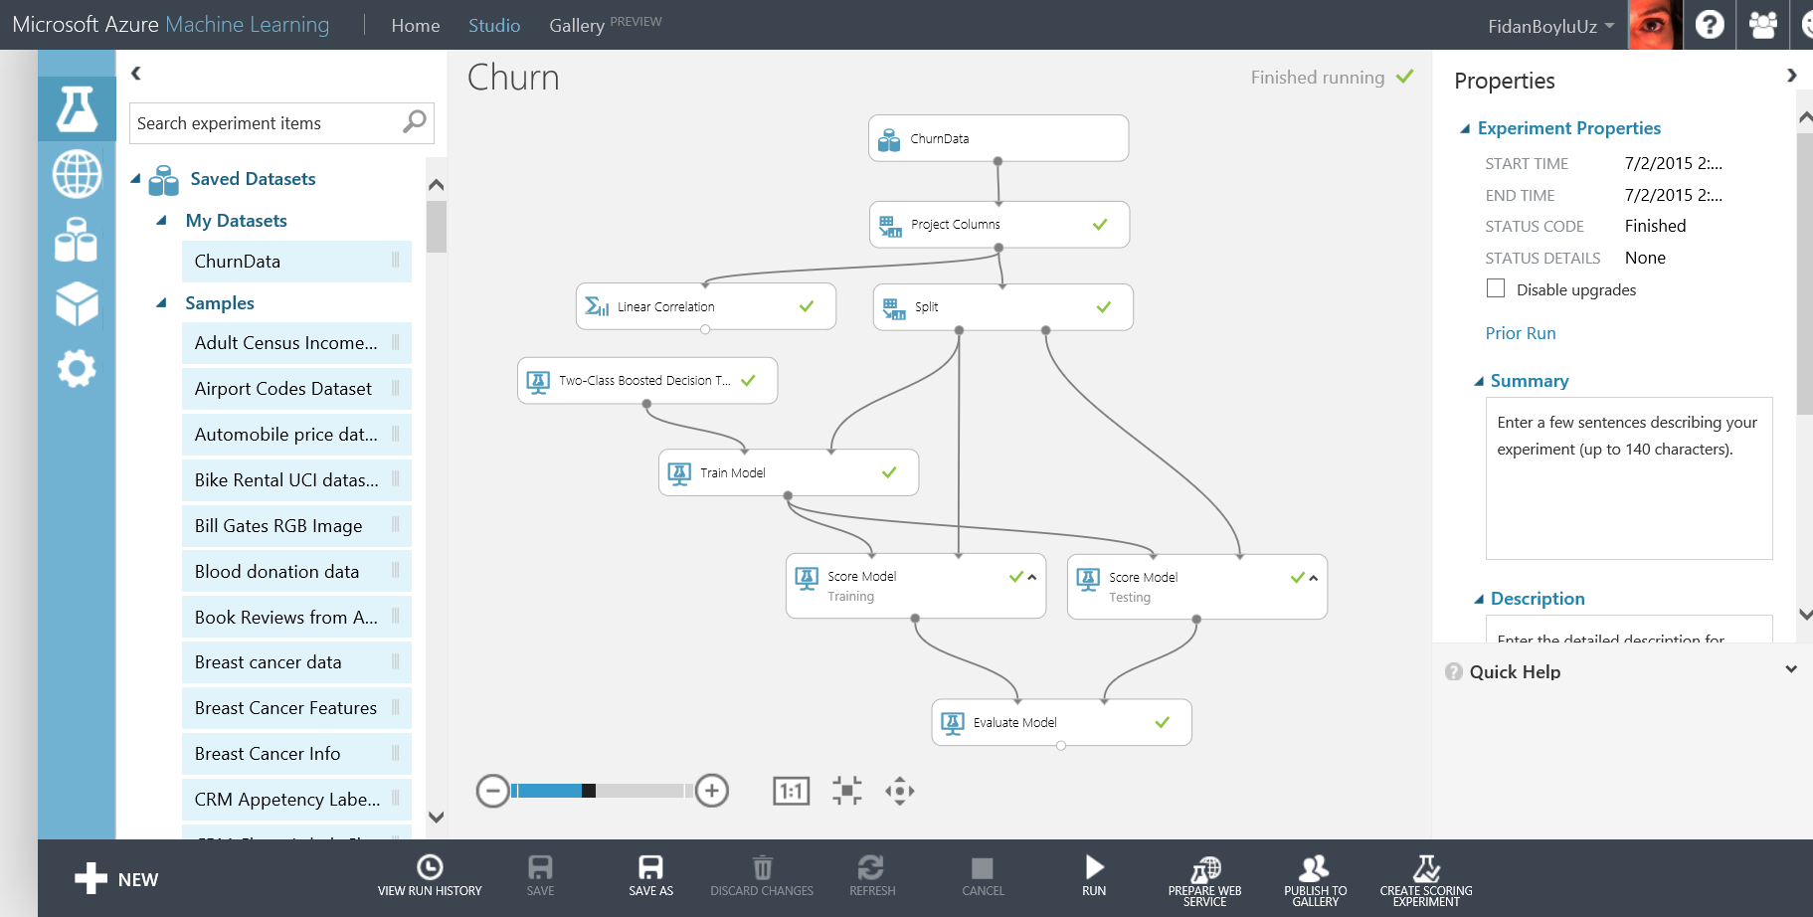

1. Right click the **Evaluation results** output port of **Evaluate Model** and select **View Results**

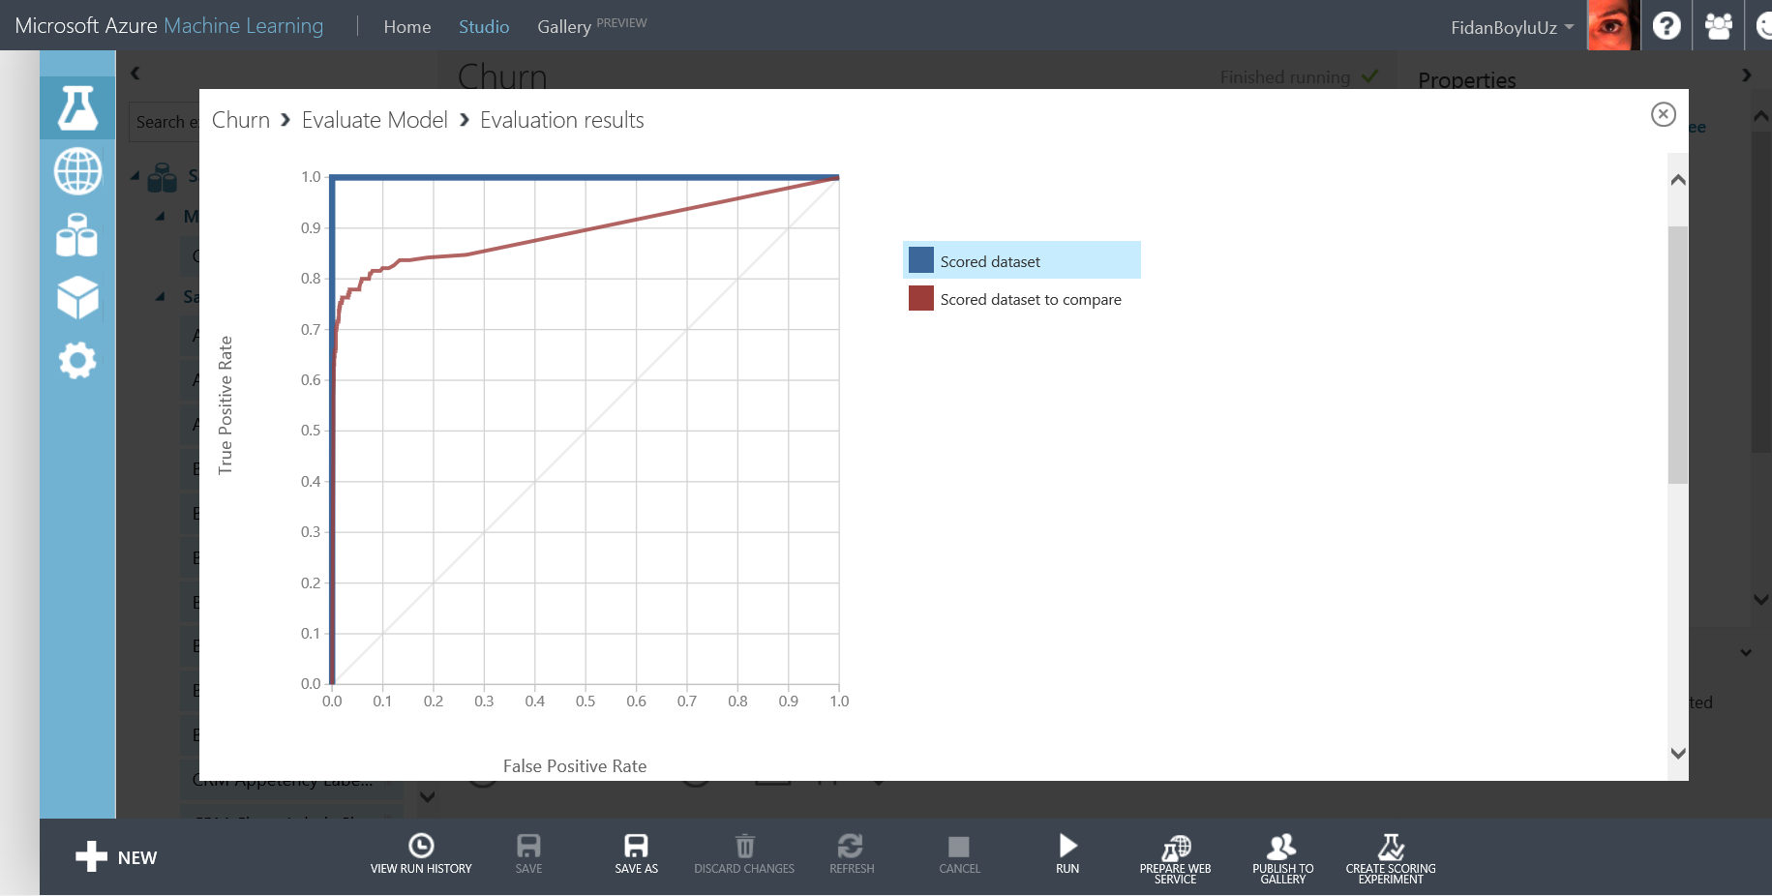

1. Notice that you are looking at **ROC** curves of both the training and test sets interlayered on top of each other for easy comparison. Also, when you scroll down the window, you will find the misclassification matrix. The blue curve (highlighted on the legend) belongs to the training set and shows that the classifier has perfect performance since the training dataset has no misclassifications (**False Positive**s or **False Negatives). AUC** is calculated as the area under the **ROC** curve which maps performance into a single scalar. The ROC curve is a two-dimensional representation of a model's performance. A perfect model will score an AUC of 1, while random guessing (diagonal line stretching from (0,0) to (1,1)) will score an AUC of 0.5.
2. Now, highlight the red curve by clicking the legend to examine the test set performance. You can see that the test set AUC is lower than the training set meaning that the classifier made errors on the test data. Now observe the confusion matrix for TP, FP, TN and FN counts. 18 data points were misclassified as false positives and 49 as false negatives. Close the window to return to the experiment.

# Executing R scripts

In this exercise, you will use the **Execute R Script** module to fit a decision tree algorithm to the churn data and visualize it by using the pre-installed R package called **Party** within Azure ML. The purpose of this section is to get you introduced to the functionality in general and is not intended to dive into R scripting or to provide a detailed description of the package used.

**Key Points**

1. Azure ML can easily be extended with open source R packages and scripts to complement the existing modules.

**Step-by-Step**

This exercise takes about 10 minutes to complete.

1. First, we will create a new experiment called Churn Decision Tree. Click the **SAVE AS** button at the bottom bar and type Churn Decision Tree for the experiment name and click the check mark. You will see that your experiment is renamed. You now have multiple experiments in your workspace. You can verify that by clicking the experiments tab on the leftmost navigation bar. Notice that a preview of the experiment is displayed on the right side.

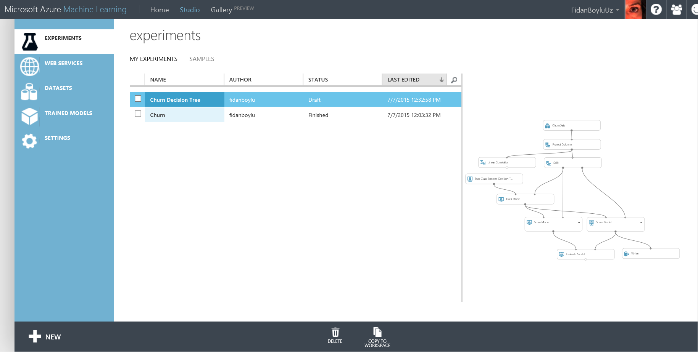

1. Click on the Churn Decision Tree experiment, delete all the modules except ChurnData and Project Columns. Next, type **Metadata Editor** in the search box and drag and drop the module on the experiment canvas and connect it to the Project Columns. Click **on Launch column selector** on the properties section and on the **Select columns** window, make sure that the first drop down menu next to **Begin With** has **No columns**, next one is **Include** and the last one is **column names.** Click the text box next to it and select **State, Int_l_Plan, VMail_Plan** and **Churn_** and click the check mark to confirm your settings.
2. Under the properties of the module, Change the Categorical setting to **Make Categorical.** Your settings should look like the screen shot below.

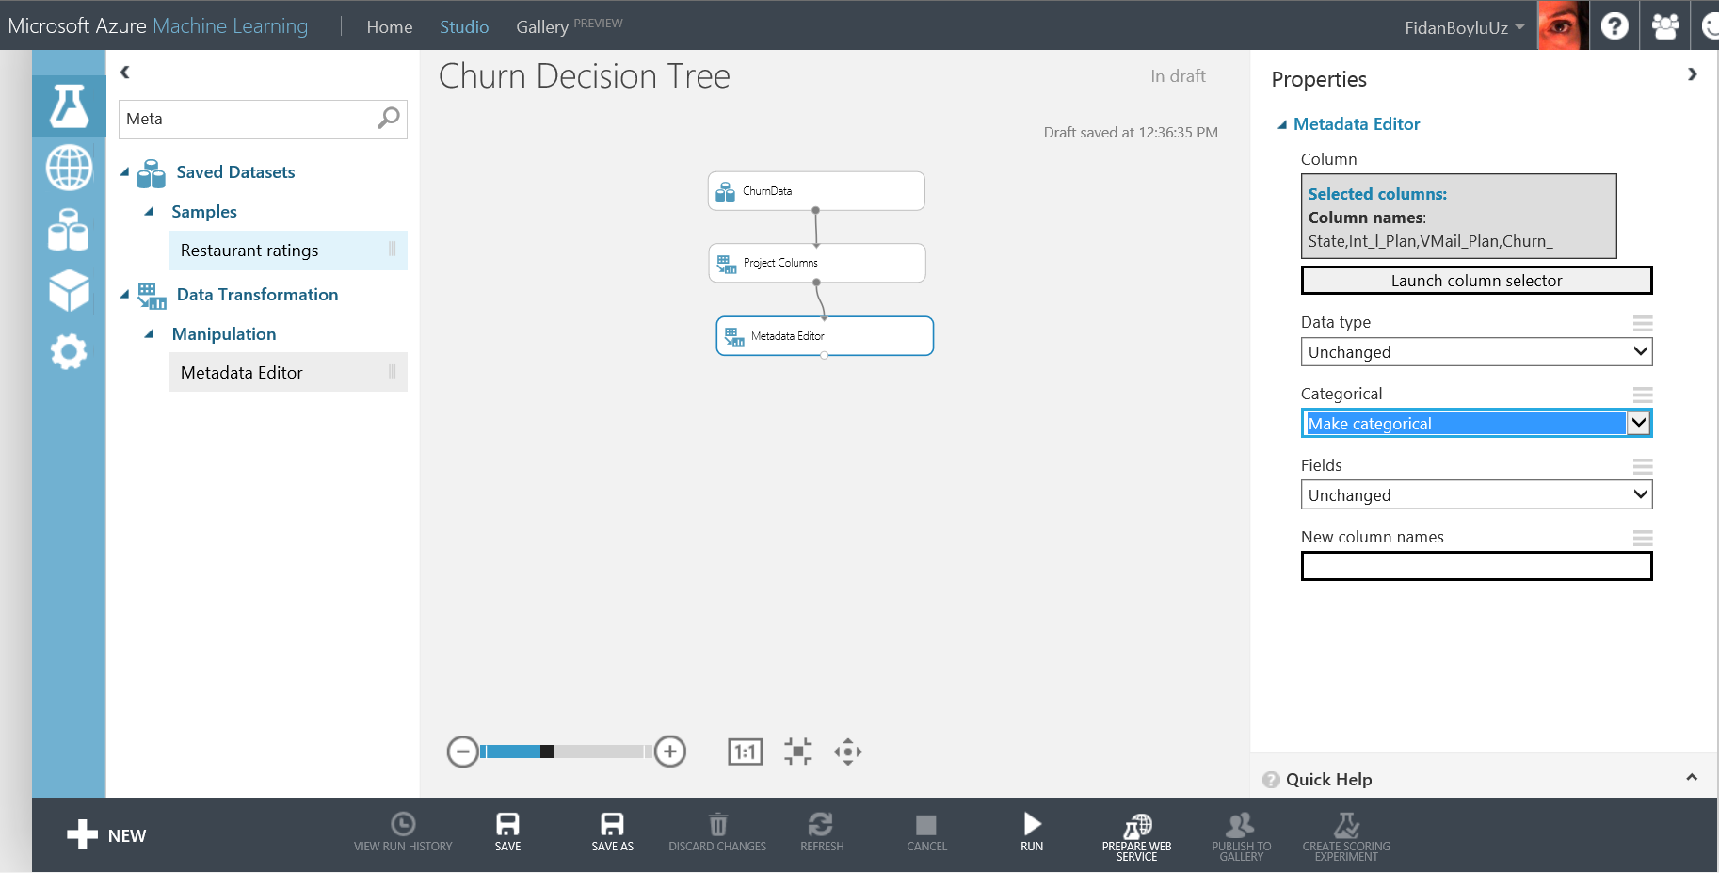

1. Next, type **Execute R Script** in the search box and drag the module and connect its first input port to the output port of **Metadata Editor**. Replace the contents of the **R script text** box on the Properties panel with the following (you can also find a copy of the script under C:\Lab1 folder):

*# Map 1-based optional input ports to variables*

ChurnData <- maml.mapInputPort(1) # class: data.frame

library(party)

model<- ctree(Churn_~ . ,data= ChurnData,control = ctree_control(maxdepth=3))

plot(model, main = 'Churn Decision Tree')

print(model)

ChurnResponse<-as.data.frame(treeresponse(model))

ChurnProb<-as.data.frame(t(ChurnResponse))

ChurnPred<- data.frame(ChurnData$Churn_, predict(model),ChurnProb[,2])

colnames(ChurnPred)<-c("Churn_","Scored Label","Scored Probability")

*# Select data.frame to be sent to the output Dataset port*

maml.mapOutputPort("ChurnPred");

1. Run the experiment. After it is finished, it should look like the screenshot below:

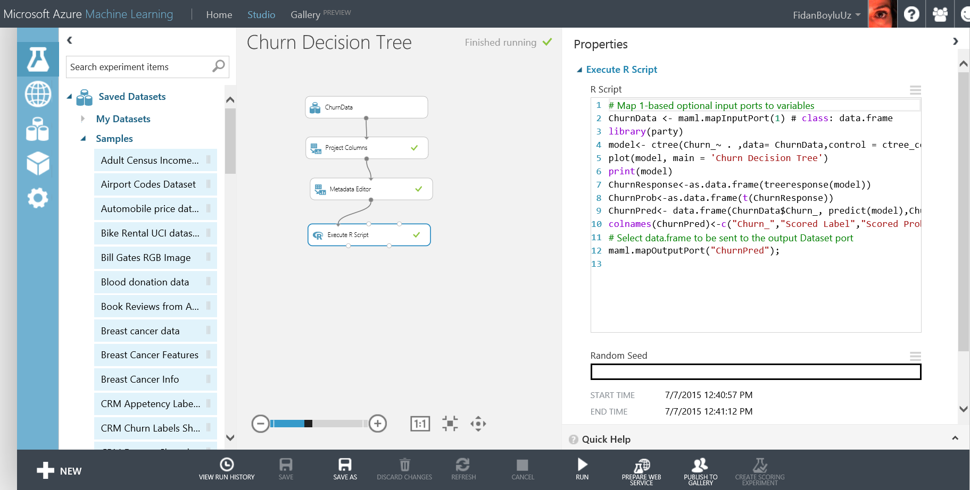

1. The above script calls the R package **Party (**[**http://cran.r-project.org/web/packages/party/index.html**](http://cran.r-project.org/web/packages/party/index.html)**)** and computes a small decision tree with 3 levels and also outputs the predicted labels and probabilities. Right click the left output port of Execute R module and **View Results** to observe the predictions of the decision tree that was trained on the whole dataset.

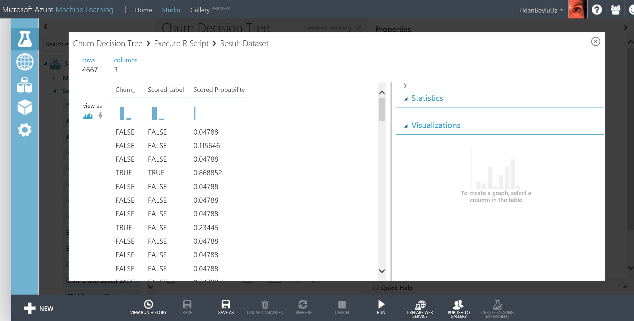

1. Close the window and this time right click the second output port of the Execute R script module and **View Results**. You will fist see the split rules generated by the package and as you scroll down you will find the plot of the decision tree that was just computed. Please refer to the package documentation provided at the link above for more details of the usage of the functions included in the package and their outputs.

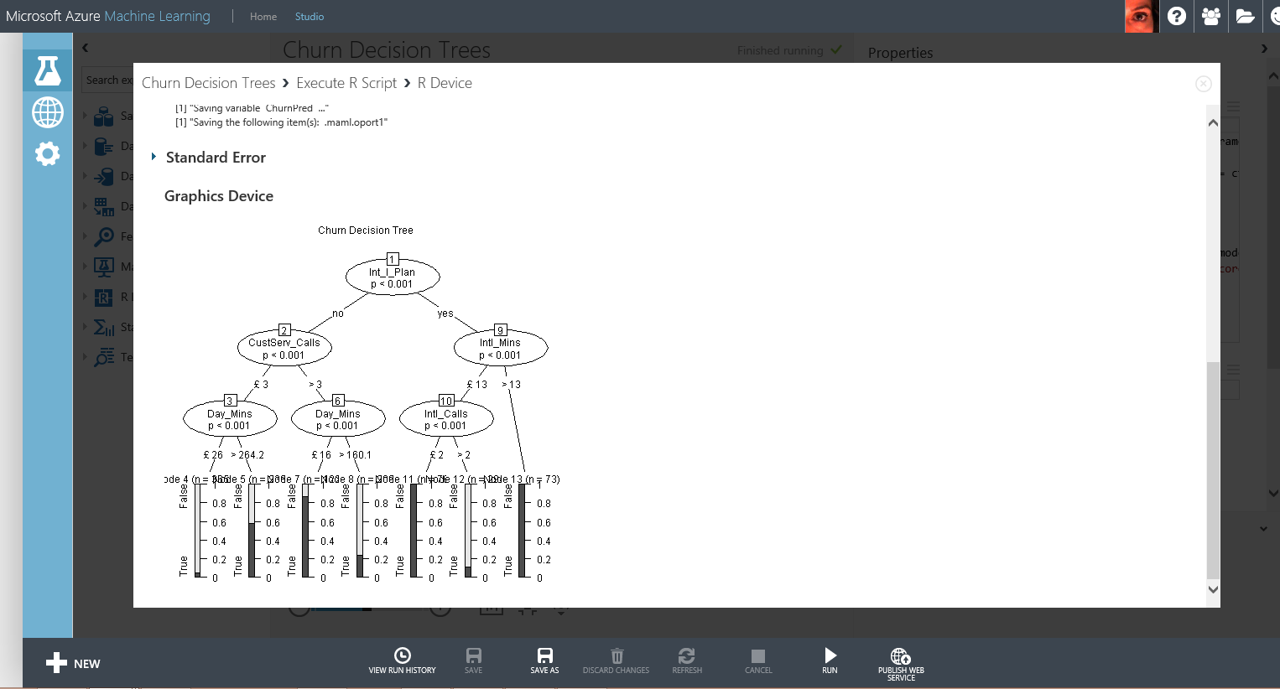

1. Next, place another **Execute R Script** on the experiment canvas and connect its first input port to the output port of **Metadata Editor**. Replace the contents of the **R script text** box on the Properties panel with the following (you can also find a copy of the script under C:\Lab1 folder):

# Map 1-based optional input ports to variables

ChurnData <- maml.mapInputPort(1) # class: data.frame

library(ggplot2)

# Scatter plot of Account_Lenght vs CustServ_Calls by churn

ggplot() +

facet_wrap(~Churn_) +

layer(

data=ChurnData,

mapping=aes(x=Account_Length, y=CustServ_Calls, color=Int_l_Plan),

geom="point",

position=position_jitter()

)

# Select data.frame to be sent to the output Dataset port

maml.mapOutputPort("ChurnData");

1. The above script calls the R package ggplot2 **(**[**https://cran.r-project.org/web/packages/ggplot2/index.html**](https://cran.r-project.org/web/packages/ggplot2/index.html)**)**

and creates scatter plots of Account_Lenght and CustServ_Calls by faceting according to Churn_ column. When finished your experiment should like the below:

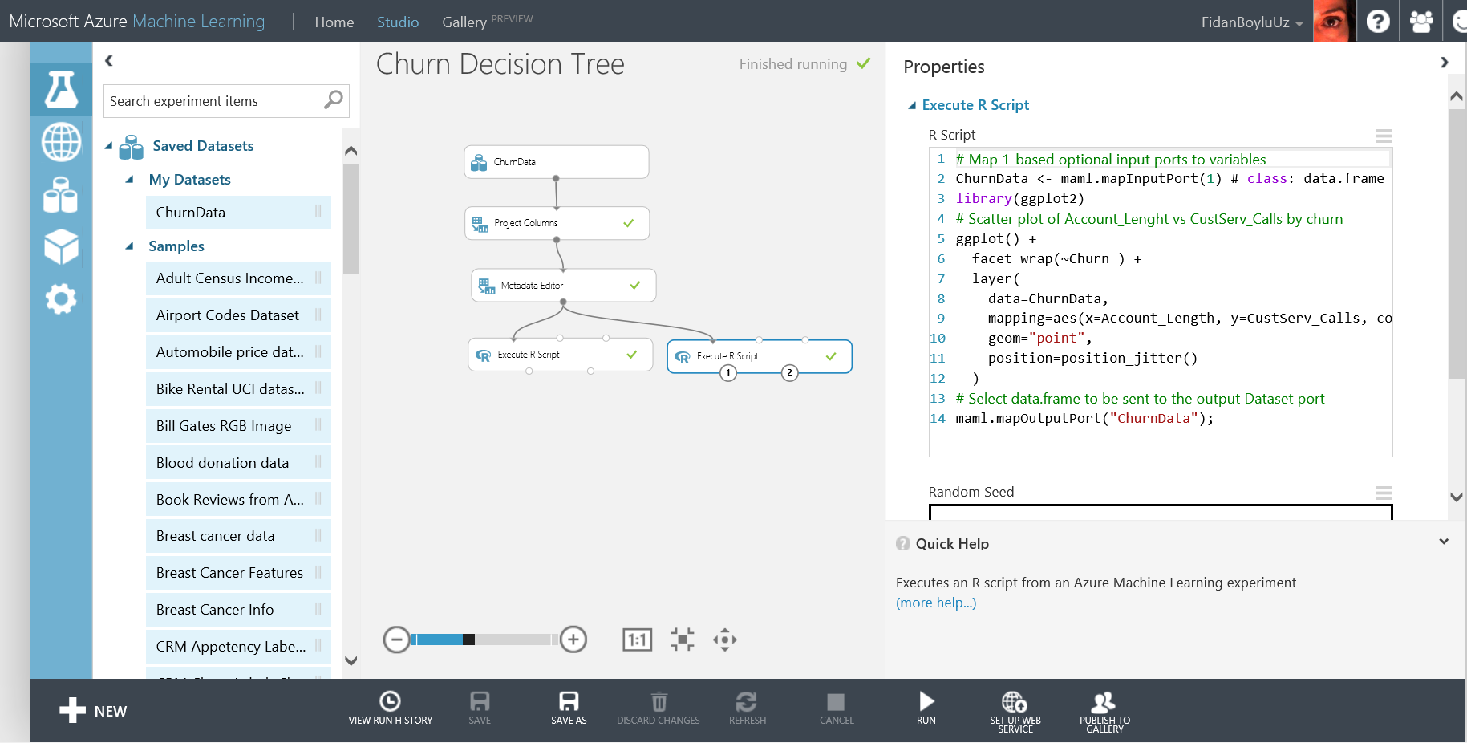

1. Right click the left output port of Execute R module and **Visualize** to observe the plots generated by the script.

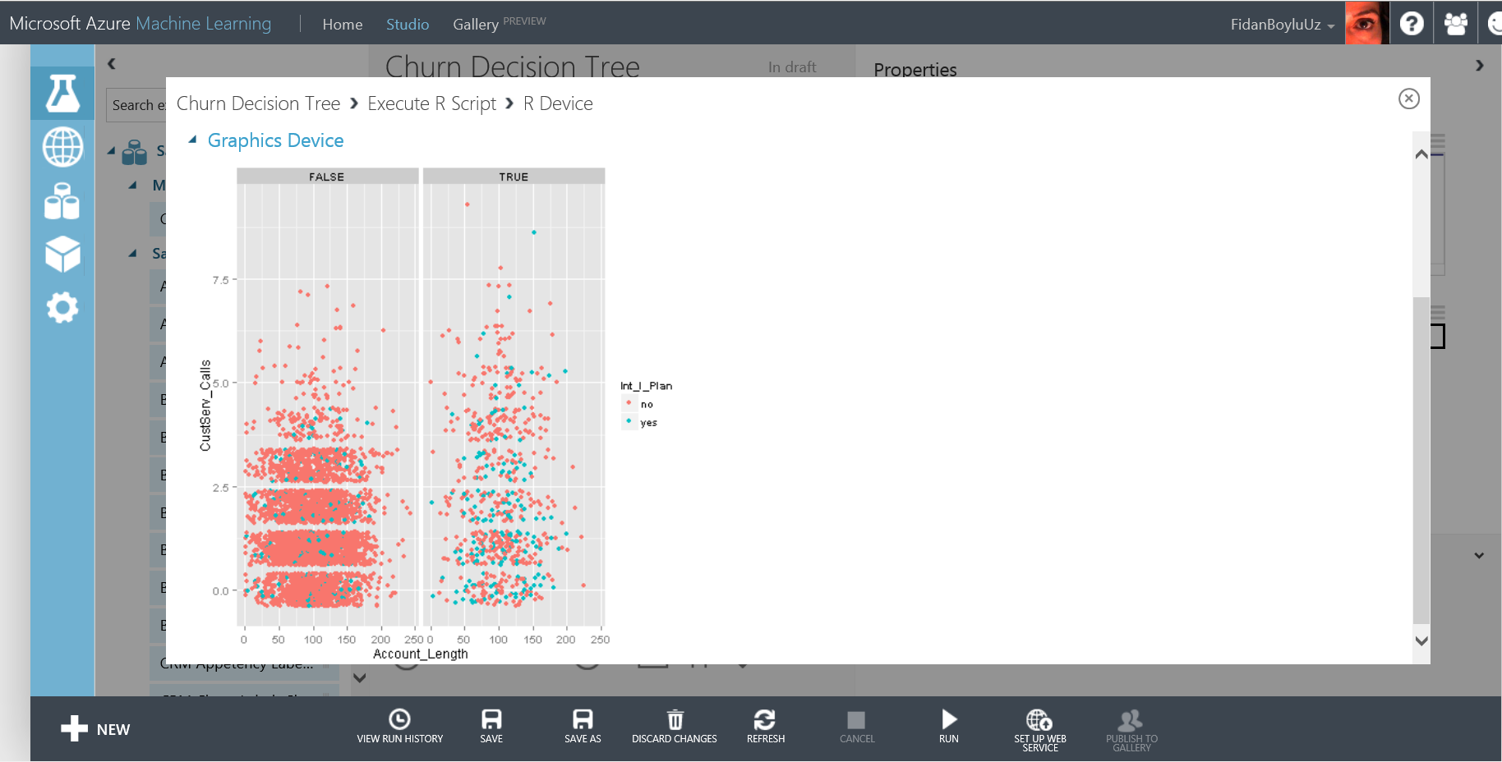

# Creating a web service for binary classification model

In this part, you will create a Web service for the Churn experiment that you created before, operationalize and deploy your model to production.

**Key Points**

1. After creating the web service, you will use the test option to verify the RRS (request response service) is operational.
2. Azure ML provides example code snippets in different languages (C# etc.) that can be used to call the service from within different custom applications.

**Step-by-step**

This step takes about 15 minutes to complete.

1. Return to the binary classification experiment named Churn, make sure the status of the experiment in the upper right hand corner of the page is **Finished**. Right click the output port of the Train Model module and select **Save as Trained Model** to save the model that will be used for the web service. Enter **Churn Model** as the name of the new trained model and click the check mark.

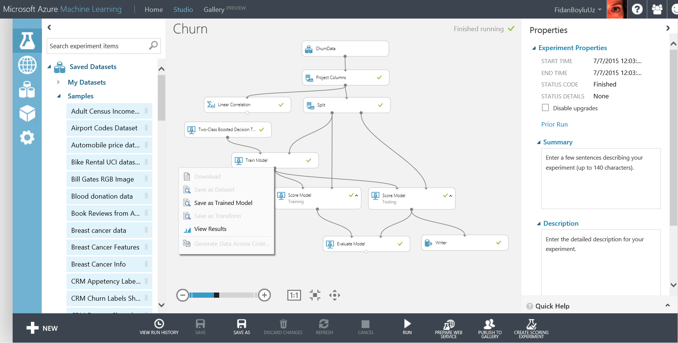

1. Next, using the **SAVE AS** button on the bottom pane, save the experiment as **Churn Scoring Experiment.** You will modify this experiment in order to publish the web service.
2. Now, delete all the modules except the ones in the picture below, keep one of the Score Model modules and make the necessary connections. Change the name of the Score Model module as **Web Service Scoring.**

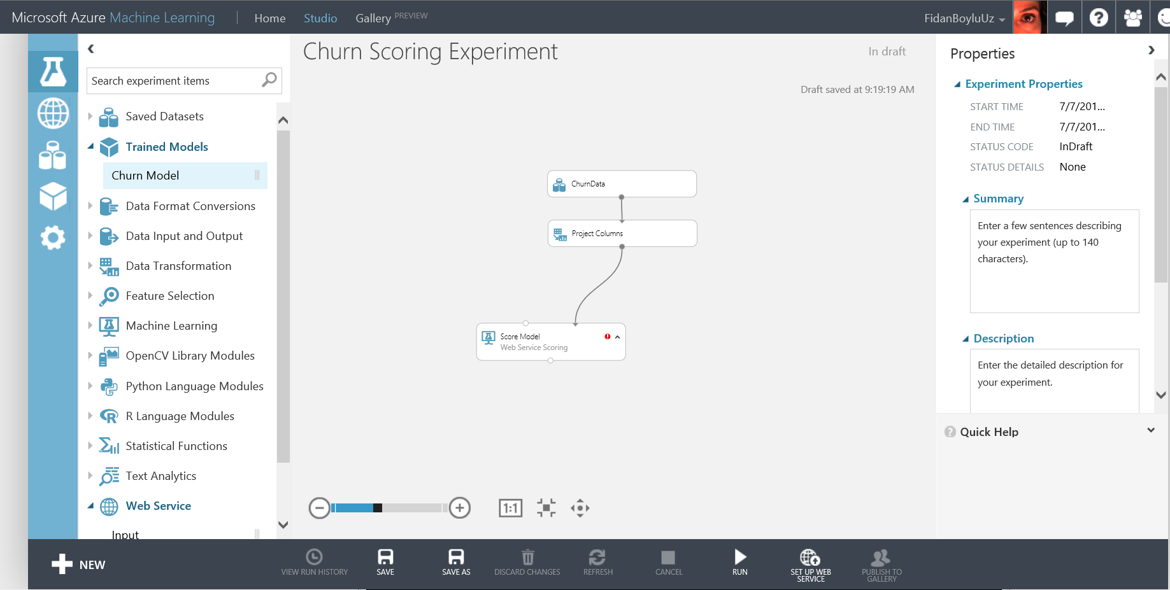

1. On the left side pane, expand the **Trained Models** category and drag and drop the **Churn Model** module to the experiment and connect it to the Score Model module.
2. Additionally, under the **Web Services** category (at the very bottom of the list), find **Input** and **Output** modules and drop them on the experiment. Connect the output of the **Web service input** module to the right input of Score Model module to set it as web service input. This port will define the input schema of the web service call**.** Similarly, connect the output port of the Score Model module to the input port of **Web service output**. This defines the output schema of the web service.

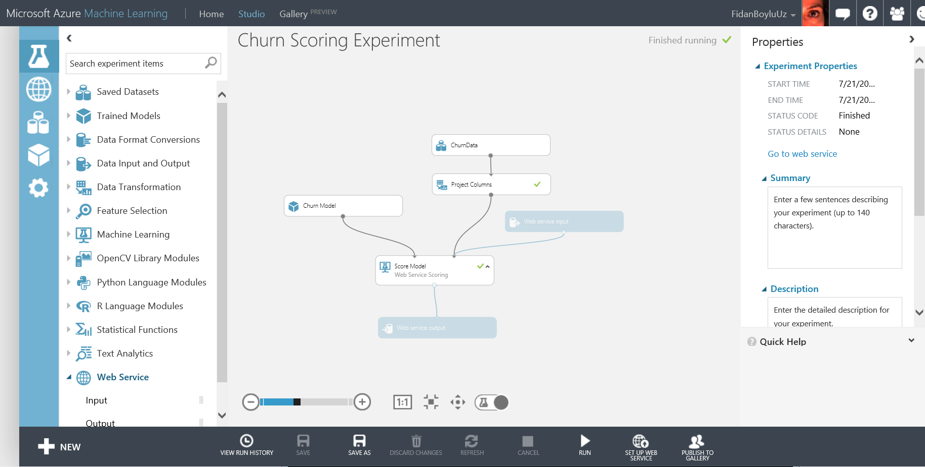

1. Run the experiment and once it is finished, click **SET UP WEB SERVICE** at the bottom bar and select **Deploy Web Service**. Select **YES** if prompted, this will take you to the web service dashboard. Observe the API key and help page links.
2. To test the service, click on the blue **Test** button in the second column of the Default Endpoint table at the bottom of the page. When **Enter data to predict** window pops up, enter the following values: State: NJ, Account_Lenght: 127, Intl_Plan: no, Vmail_plan: no, Vmail_message: 0, Day_mins: 245, Day_calls:91, Eve_mins:217, Eve_calls:92, Night_mins:243, Night_calls: 128, Intl_mins:14, Intl_calls: 6, Custserv_calls: 0, Churn_ :null.

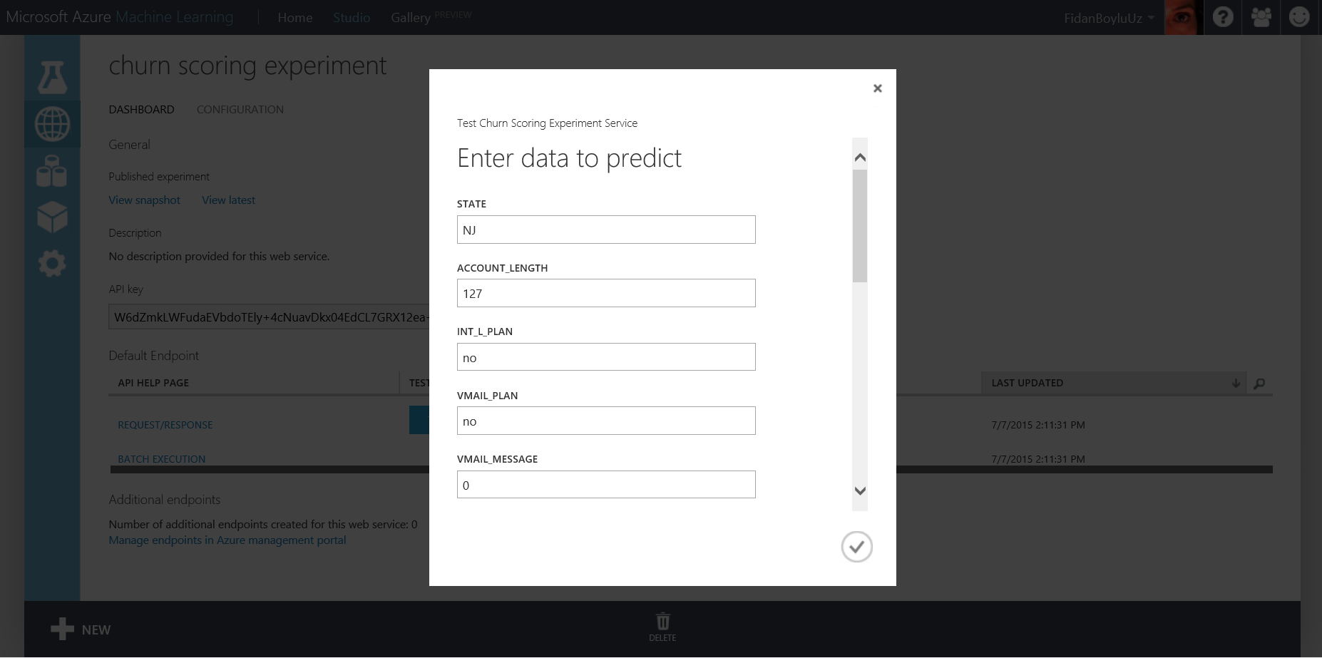

1. Click on the checkmark, then click on the green stacked bars at the bottom right corner of the screen then click **DETAILS**. You will see a test return confirmation message with the **Result: NJ, 127, no, no, 0, 245, 91, 217, 92, 243, 128, 14, 6, 0 ,null,TRUE,0.842720925807953**. The last two values represent the churn model prediction for this customer where the predicted probability for this customer’s likelihood to churn (TRUE) is approximately 84.27%.

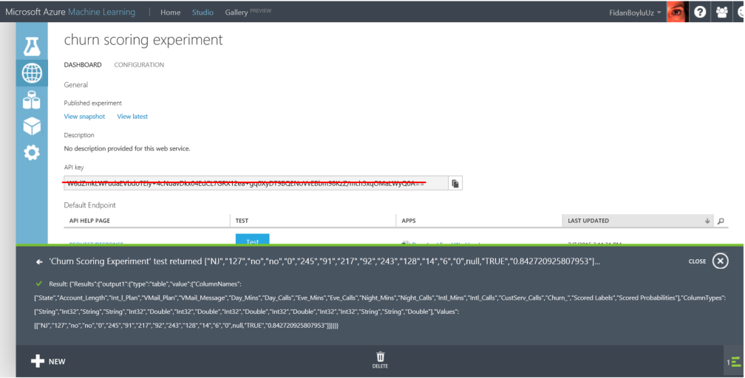

1. Close the message bar and under the APPS column click on **Download Excel Workbook**. Save the workbook under C:\Lab1\ and open the file. Click **Enable Editing** on the yellow bar on the top and then **Enable Content**. Select yes on the Security Warning pop-up window. Under the sample row with all zeros, you can now enter the same test values as before (State: NJ, Account_Lenght: 127, Intl_Plan: no, Vmail_plan: no, Vmail_message: 0, Day_mins: 245, Day_calls:91, Eve_mins:217, Eve_calls:92, Night_mins:243, Night_calls: 128, Intl_mins:14, Intl_calls: 6, Custserv_calls: 0, Churn_: null ) and observe the real time prediction call made to the web service from excel.

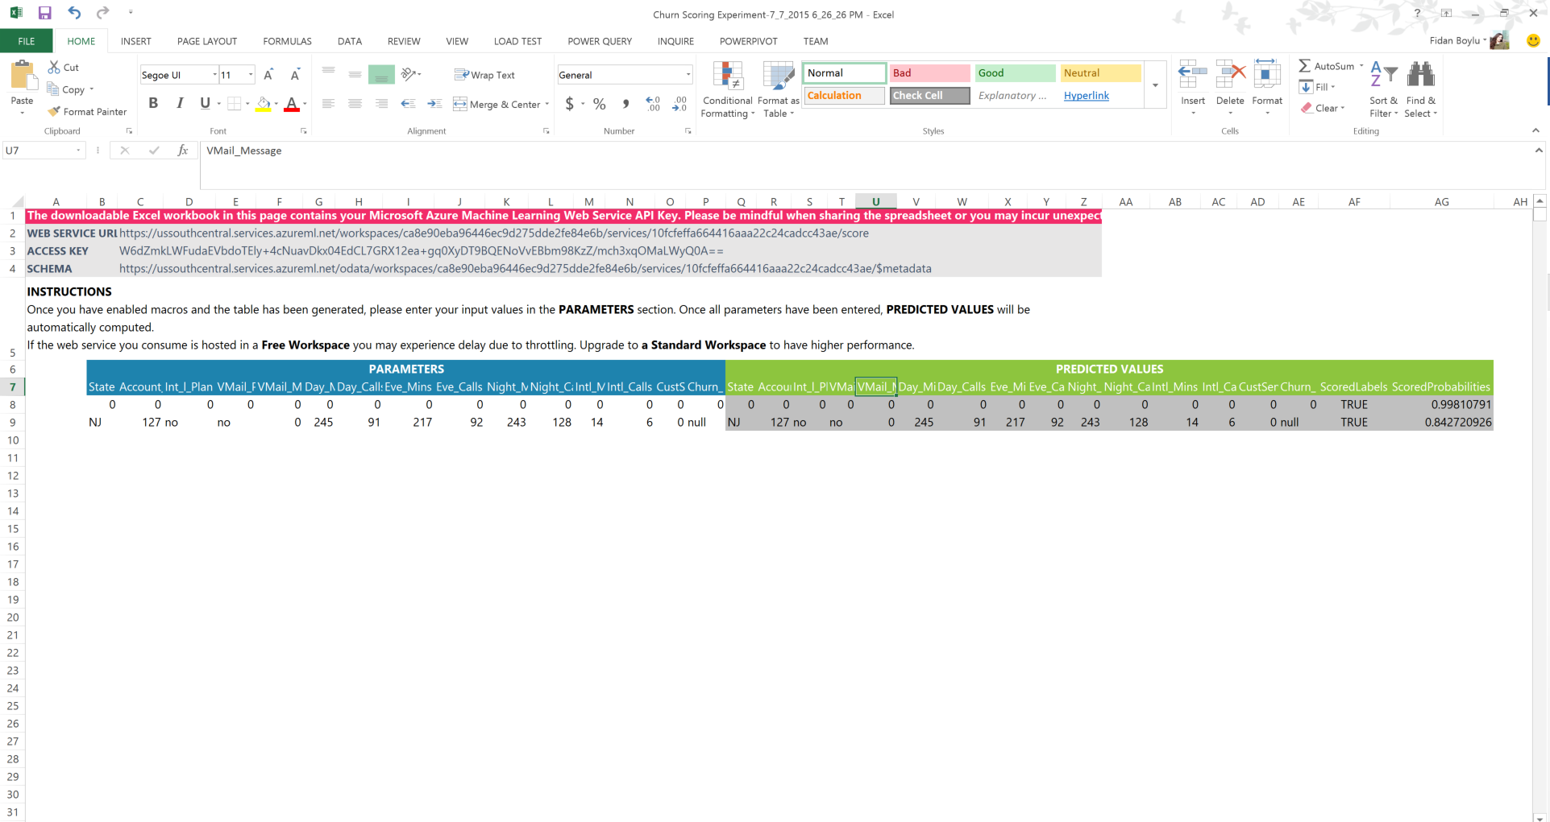

# Azure ML Web service call from RStudio

In this optional exercise, you will use RStudio to make a call to the web service you created earlier.

**Step-by-step**

1. Go back to your browser to the web service dashboard. Click the **REQUEST/RESPONSE** link under the **API HELP PAGE** heading. This will direct you to the Request Response API Document for your service. You will find your Web service URI on this page along with Sample Code to call the web service using C#, Python and R when you scroll down to the bottom. We will make use of the R sample code in this exercise.

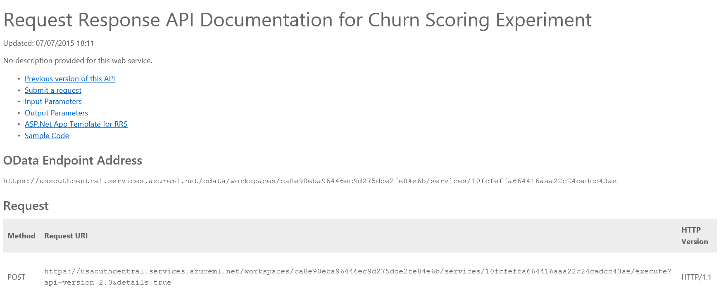

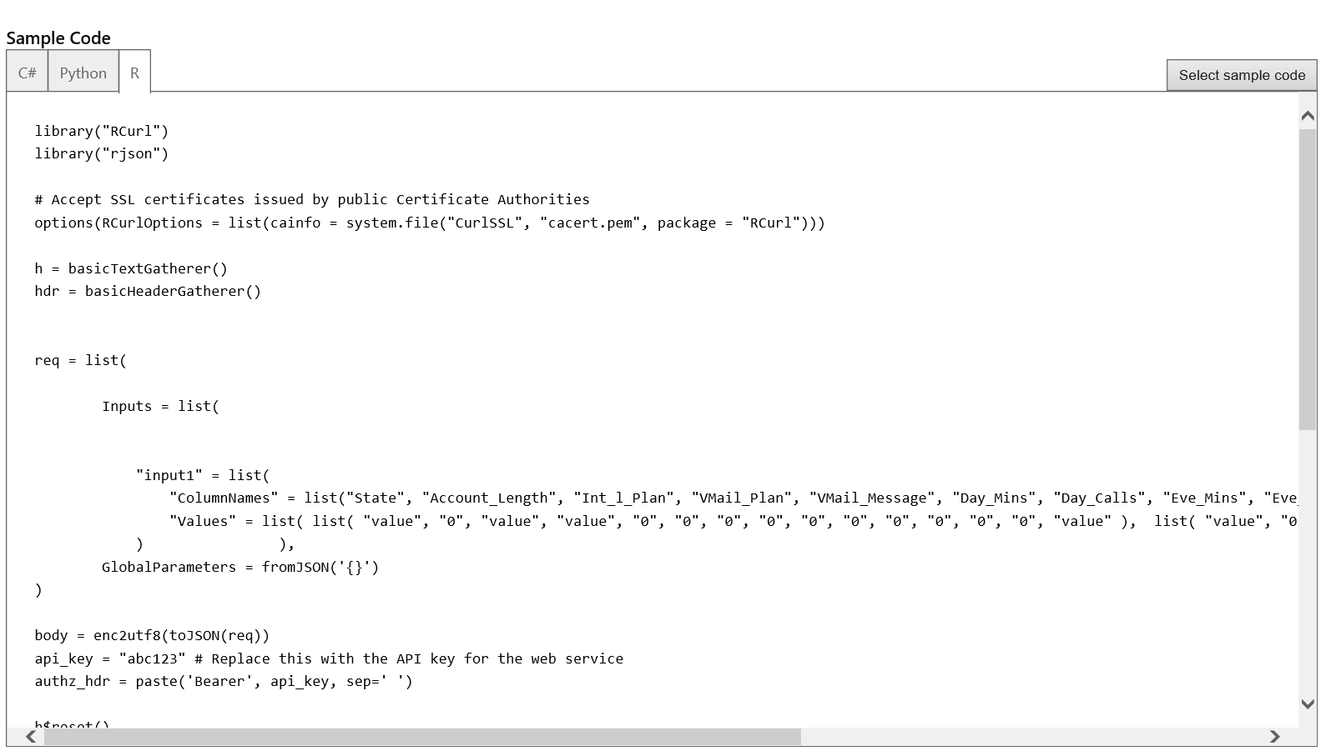

1. Now, on the task bar find **RStudio** and start the program. Under File menu, click Open File and browse to C:\Lab1\ and open **R_Script_API** file. This will load the sample script to your **RStudio.**

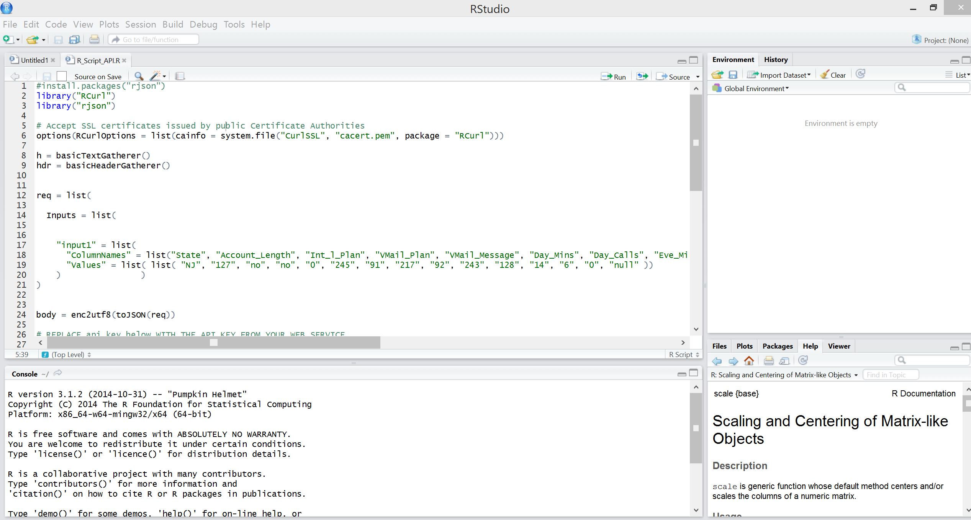

1. Scroll down the script and locate the comments: # REPLACE api_key below WITH THE API KEY FROM YOUR WEB SERVICE and # REPLACE URI BELOW WITH THE URI FROM YOUR WEB SERVICE. Replace the api_key by copying the API key from your we service dashboard under API key column. Also, find your URI on the Request Response documentation page and replace the URI in the script with yours. Observe the inputs list where same input values to test the service from the earlier exercises are provided. Now, select and highlight the whole script and click Run on the upper right corner of the script window. Wait for the script to execute. You can follow progress on the Console window. After script is finished, you should get the following console output:

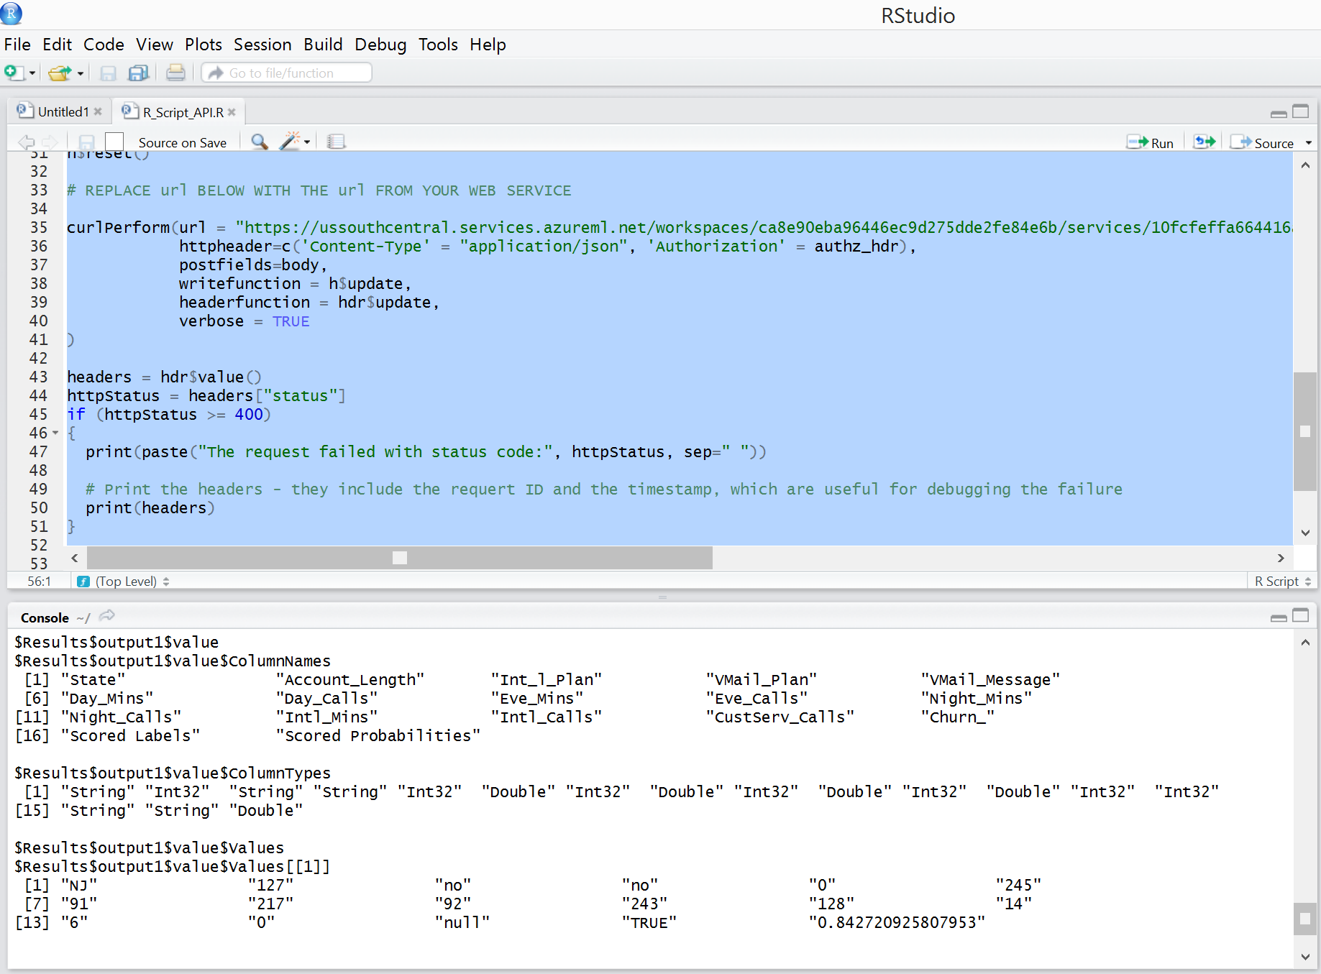

# Visualizations for classification using Power BI

In this section, you will use Power BI Desktop to visualize the scored labels of the classification model you have developed earlier.

**Key Points**

1. In the earlier sections, you have used a writer module to write your predictions to an Azure SQL database.
2. Power View and other visualization tools and techniques can be used to visualize the results of the models like the scored datasets by importing the data from Azure SQL database into Power View. For this exercise you will work with a file with already exported data.

**Step-by-step**

This step takes about 20 minutes to complete.

1. Open the file **C:\Lab1\ ChurnDataTestScores – Start.xlsx** using Excel. The tab ChurnDataTestScores has the imported data. This Excel file also has a PowerPivot model. Please spend a few minutes making yourself familiar with the PowerPivot Model, make sure to examine the Measures that were created and also the additional columns. **Note**: If you are not comfortable with PowerPivot and Power View and prefer to analyze the solution for this exercise you can open the file C:\Lab1\ ChurnDataTestScores - Solution.xlsx.
2. Create the Scored churn by State report:
3. Insert a new Power View report and title it **Scored churn by state**.
4. From **Power View Fields** select the following fields: **State** and **Score Labels.**
5. Switch the visualization to Map and change its size for a better visualization. Drag the Scored labels field from the Power View Fields into the Σ SIZE.

In this visualization you can see that people in California is more inclined to change phone carrier than in other states.

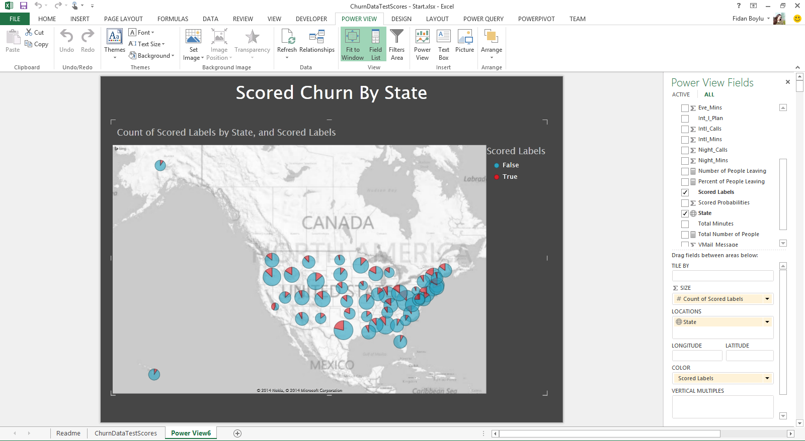

1. Create the Account Longevity and Location Analysis report:
2. Insert a new Power View report and title it **Account Longevity and Location Analysis**.
3. From **Power View Fields** select the following fields: **State** and **Percent of People Leaving.**
4. Switch the visualization to Map and change its size to use half of the screen.
5. Click on the blank part of your report and then, from **Power View Fields** select the following fields: **Account Longevity** and **Percent of People Leaving.**
6. Switch the visualization to Stacked Bar Chart and change its size to use the reaming half of the screen.
7. Select different Account Longevity periods and note the effect it has on the map. You can also try selecting different states and see the effect on the account longevity.

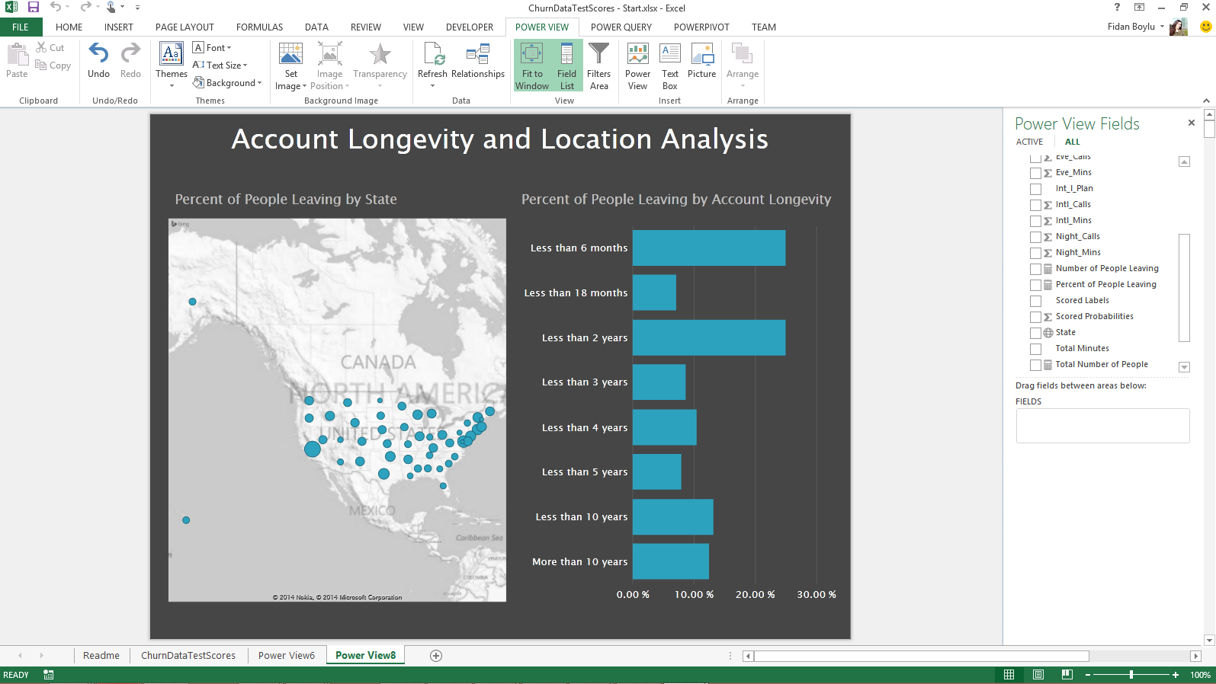

1. Create the Account Details Analysis report:
   1. Insert a new Power View report and title it **Account Details Analysis**.
   2. From **Power View Fields** select the following fields: **Account Longevity** and **Percent of People Leaving.**Switch the visualization to Stacked Bar Chart and change its size to use the top half of the screen.
   3. Click on the blank part of your report and then, from **Power View Fields** select the following fields: **Total Minutes** and **Percent of People Leaving.**
   4. Switch the visualization to Clustered Column Chart and change its size to use the reaming top half of the screen.
   5. Click on the blank part of your report and then, from **Power View Fields** select the following fields: **IntI_Plan** and **Percent of People Leaving.**
   6. Switch the visualization to Stacked Bar Chart and change its size to use the bottom half of the screen.

Note how the possession of the International Plans and use of minutes affect the inclination of people to leave the phone carrier.

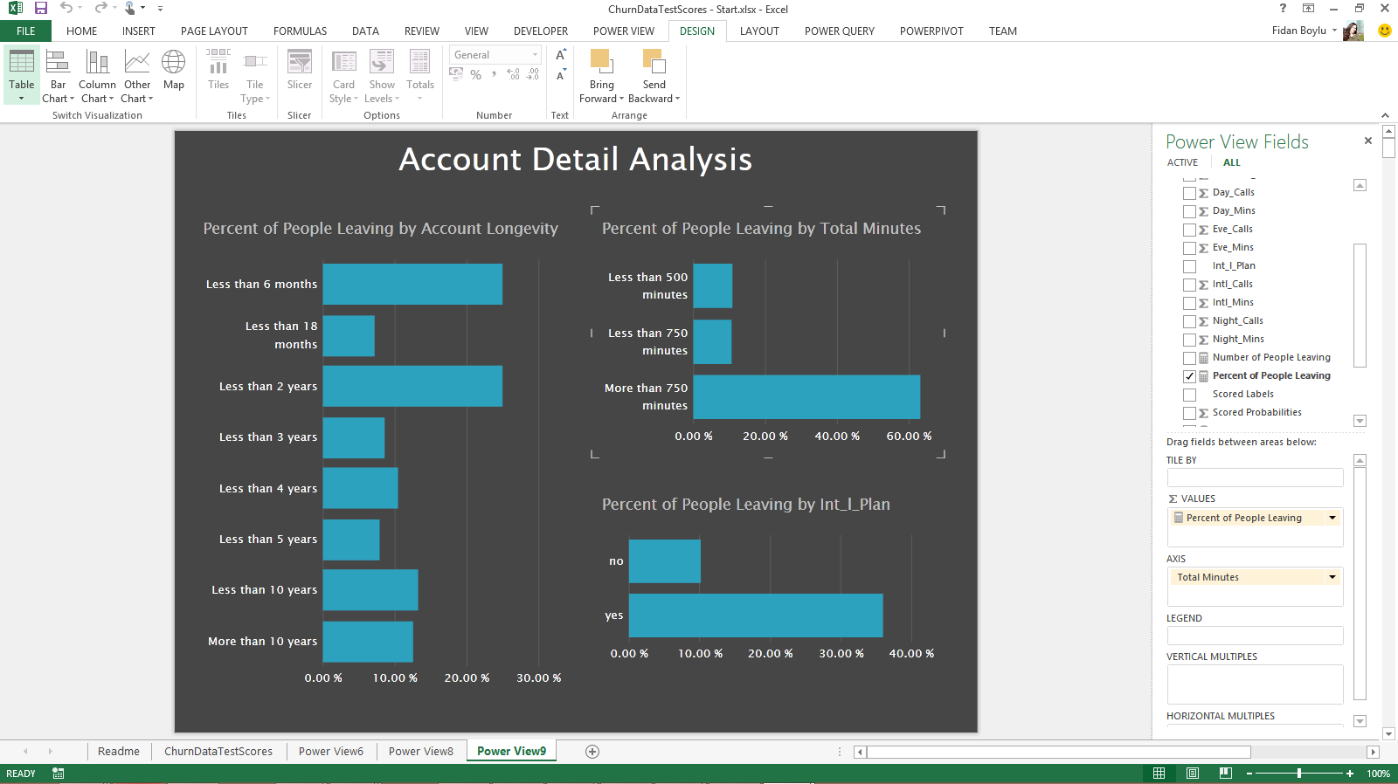

1. As a next step, if you have an O365 account, you can publish your Power View visualizations to a Power BI dashboard by uploading your workbook created above to PowerBI. Alternatively, you can connect to the Azure SQL database from Power BI and prepare your dashboard directly using the ChurnScores table in Churn database.

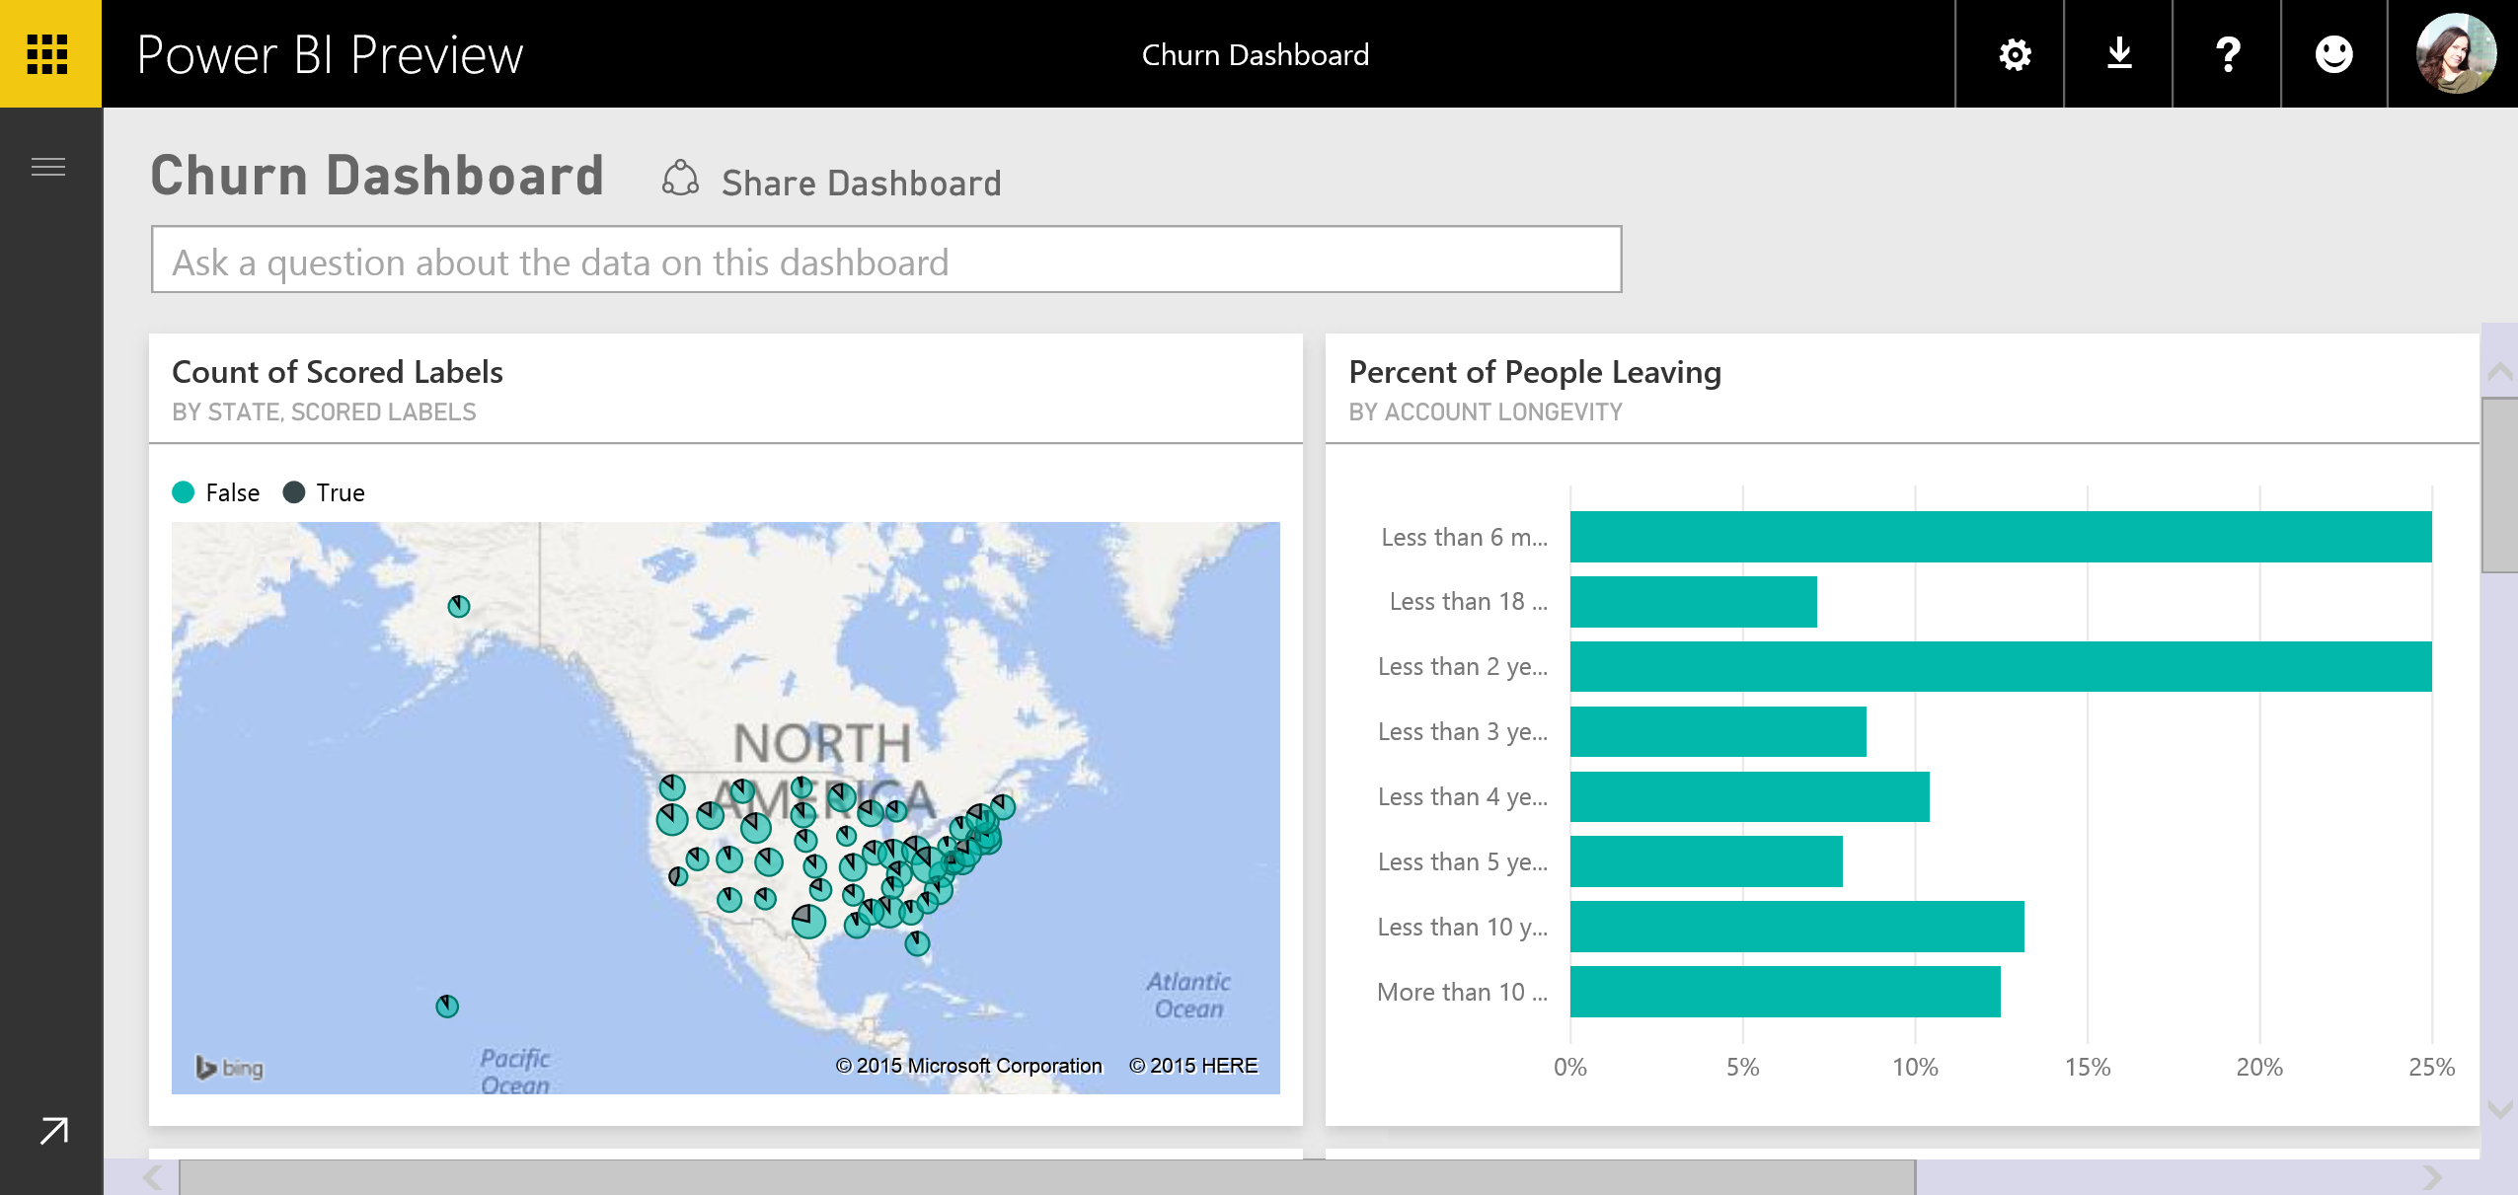

# Clustering

In this section, you will create a new series of experiments by clustering the Customer Churn data set. Clustering is an unsupervised learning technique that doesn’t require labels in the data in order to apply the algorithm. In the Customer Churn data set, labels are supplied, but we are going to ignore those labels for our current purposes.

The clustering algorithm you will use is called k-means, where k refers to the number of clusters you would like to have. In k-means, each sample in the data set is mapped into an n-dimensional feature space (where n is the number of columns, or features, you are asking the algorithm to consider). Depending on the specific implementation of the algorithm, k initial centroids, or center points of the clusters are established and then an iterative process begins. In each iteration of the process, the centroids are moved so that they are closer (using a distance formula such as Euclidean distance) to the center of a group of n / k nearest points. The iterations continue until either a static state is reached or the maximum number of iterations is reached.

**Key Points**

1. The k-Means clustering algorithm classifies unlabeled data.
2. Be careful to only include significant columns (features) in your clustering model and exclude highly-correlated features. This way, redundant, highly-correlated features will not skew your model.

**Step-by-step**

This step takes about 15 minutes to complete.

1. From literally anywhere in Azure ML Studio, create a new experiment, by clicking on the **+ NEW** button in the lower left corner of the window and then click on **Blank Experiment** box.
2. Rename your experiment by typing **Segmentation** into the title field.
3. In the Search box, search for ChurnData and drag the data set onto the canvas. You will prepare your clustering experiment against this data set.
4. Before clustering, you will first eliminate columns that are not necessary, as in the previous experiment. Search for **Project Columns** and drag that module onto the canvas.
5. Connect the **ChurnData** data set to the **Project Columns** module. Your experiment should now look like the experiment below.

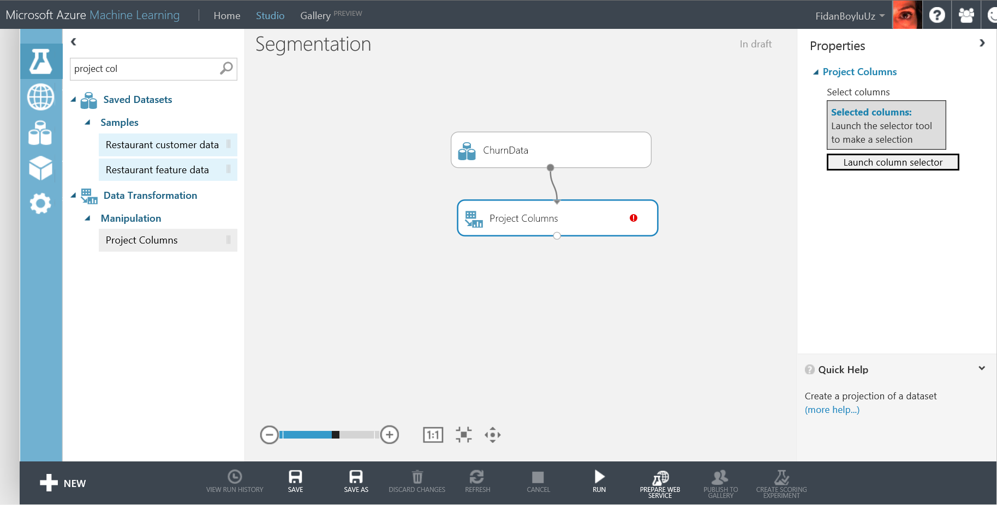

1. With the **Project Columns** module selected, click the **Launch column selector** button in the **Properties** pane and include the following columns **X_dataobs_, State, Account_Length, Int_l_Plan, VMail_Plan, VMail_Message, Day_Mins, Day_Calls, Eve_Mins, Eve_Calls, Night_Mins, Night_Calls, Intl_Mins, Intl_Calls, CustServ_Calls,** and **Churn_** as in the screenshot below. Note that some highly- correlated columns are being excluded, as in the previous experiments. Also note that **X_dataobs_** (the observation number) and **Churn_** (the label) will not be used in the clustering itself, but will be used later for visualization.

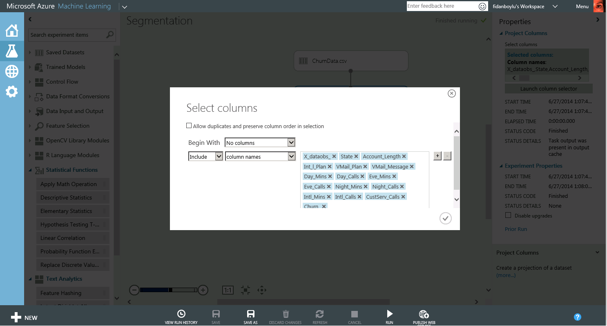

1. Click the check mark and use the Search box to find the **K-Means Clustering Model** and the **Train Clustering Model** modules and drag them onto your canvas and connect them as shown below.

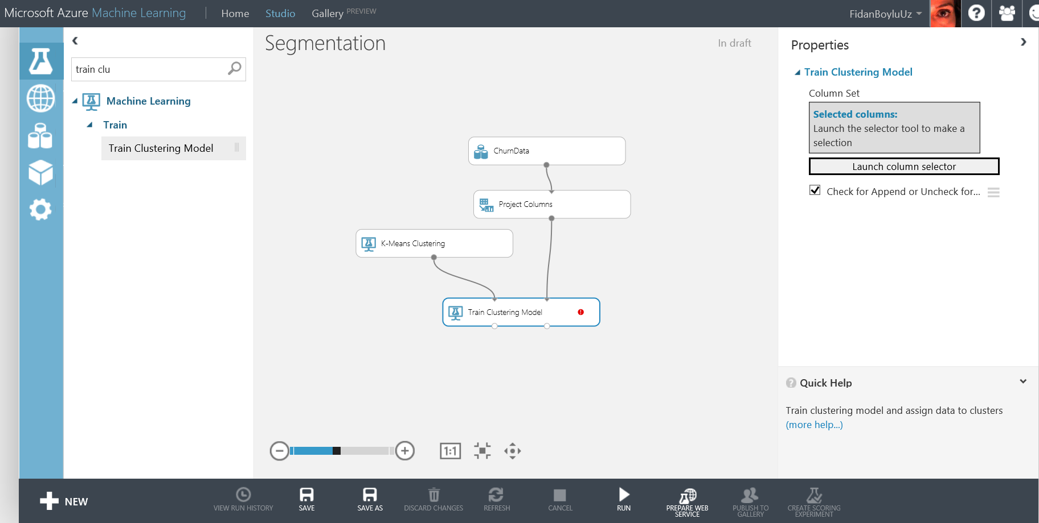

1. Select the **K-Means Clustering** module, go to the **Properties** pane and set the **Number of Centroids** (K) to 2.
2. With the **Train Clustering** module selected, select the columns that you will include in clustering and the resulting visualization, by pressing the **Launch column selector** button in the **Properties** pane.
3. Select all columns except **X_dataobs_** and the **Churn_** columns that will not be included in the clustering.
4. Use the **Search** box to locate the **Convert to CSV** module and wire it up, as shown below. **Run** the experiment.

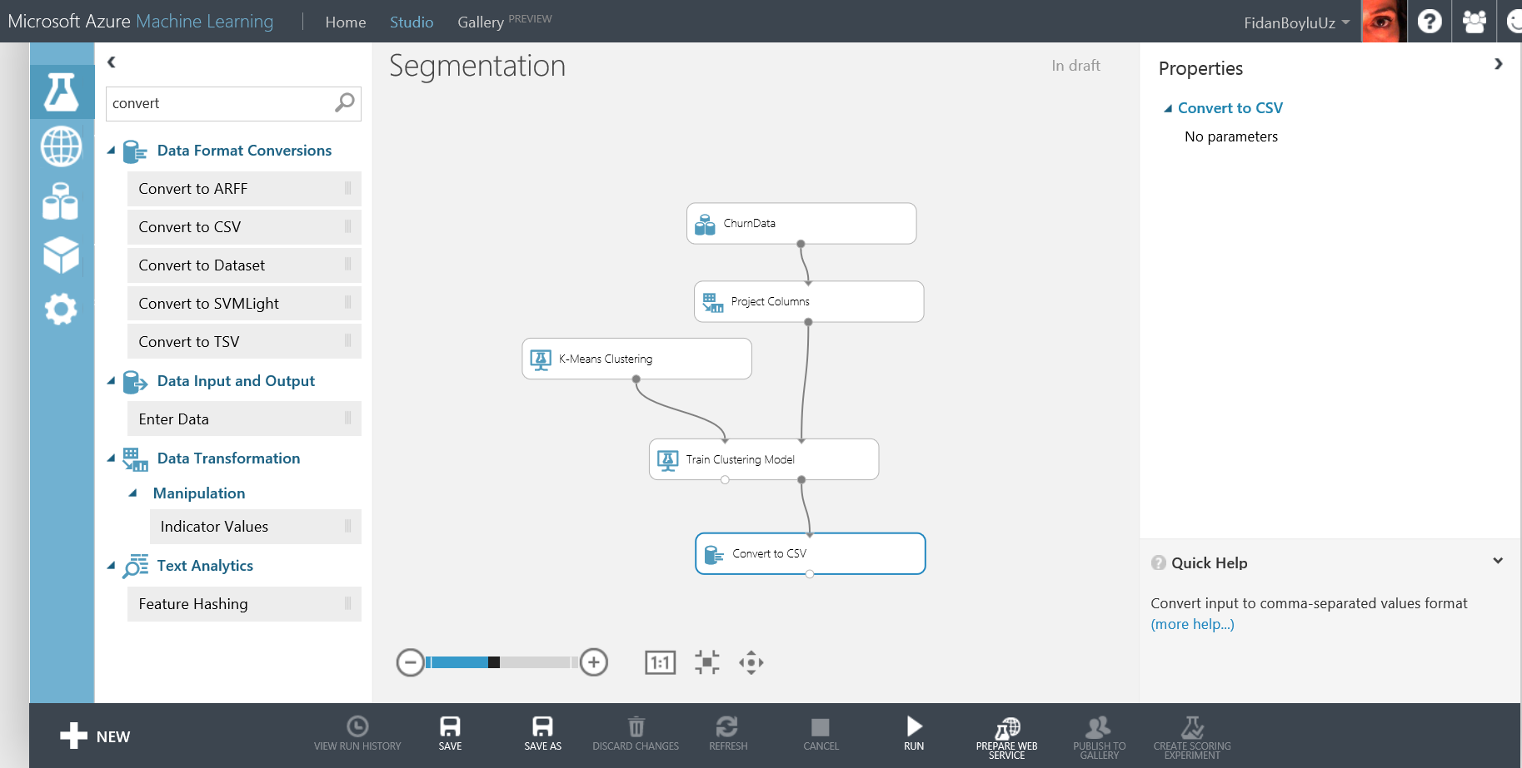

1. Once the experiment has completed, right click on the output node of the Convert to CSV module and select **Download**, as shown below.

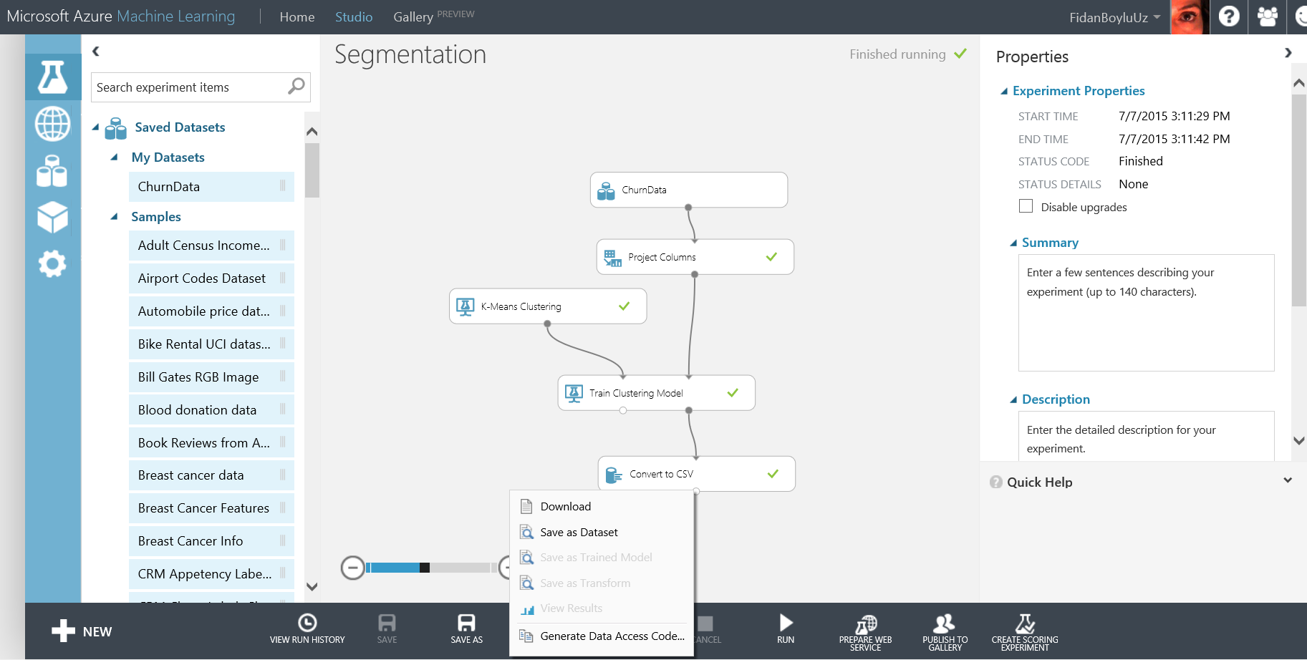

1. The Internet Explorer save dialog will appear. Save the resulting file as

**K – Means 2 .csv** where 2 is the number of clusters that you have requested.

1. Repeat the experiment by changing the cluster **Number of Centroids** parameter in the properties pane for the **K-Means Clustering Model** module to **4**.
2. Download and save the resulting CSV file as **K – Means 4.csv**.

# Summary

This lab was intended to introduce you to the basic concepts of data science such as binary classification, segmentation, training and testing a model using Azure Machine Learning. Azure SQL Server, Power view, Power BI and R scripting is used data ingestion and end user visualizations to demonstrate an integrated approach for an end-to-end solution. Finally, a web service is created to operationalize the model and excel and RStudio was used to consume the web service.